

PC649: MSc (IT) Summer Internship

# “CollegeWeb”

# A website for student to find the perfect college

# Project Members:

|  |  |
| --- | --- |
| **Laxit Shah** | **202212042** |
| **Arkan Mansuri** | **202212055** |

# 

# Mentor: Prof. Amit Mankodi

**Table of Contents**

|  |  |  |
| --- | --- | --- |
| **Sr No** | **Title** | Page No |
| 1 | Acknowledgement | 3 |
| 2 | Introduction | 4 |
| 3 | Functional Requirements | 7 |
| 4 | Non-Functional Requirements | 10 |
| 5 | Coding and API | 12 |
| 6 | Methodology | 14 |
| 7 | Design | 17 |
| 8 | Website Screenshots | 31 |
| 9 | Summary and Lesson Learned | 77 |
| 10 | Conclusion | 78 |
| 11 | Bibliography | 79 |

**Acknowledgement**

We extend our profound appreciation to our esteemed project guide, Prof. Amit Mankodi, whose invaluable support and expert guidance have been instrumental throughout the development of CollegeWeb, an innovative web-based platform facilitating college-student interactions. Prof. Mankodi's mentorship has played a pivotal role in bringing this project to fruition. His commitment to fostering our growth and sharing his expertise have been vital in shaping the success of CollegeWeb. This challenging endeavor has provided us with a unique opportunity for skill development and learning, and we are deeply grateful for Prof. Mankodi's encouragement and belief in our capabilities. Our experience in developing CollegeWeb has been nothing short of remarkable, and we owe our profound gratitude to Prof. Amit Mankodi for his unwavering support and guidance throughout this journey.

**Introduction**

In the ever-evolving landscape of higher education, technological advancements play a pivotal role in transforming the way colleges and students interact. As part of our commitment to fostering better college-student connections, we proudly present "CollegeWeb" – a cutting-edge web-based platform designed to revolutionize the college experience.

With the rapid growth of the digital era, the need for a unified and dynamic platform that empowers colleges and students to connect effortlessly has become increasingly apparent. CollegeWeb serves as a seamless bridge, providing an interactive space for colleges to showcase their unique offerings while enabling students to explore, engage, and make informed decisions about their educational journey.

The primary goal of CollegeWeb is to create an intuitive and user-friendly interface that caters to the diverse needs of both colleges and students. For colleges, the platform offers a powerful website creation tool, allowing them to effortlessly build customized websites that showcase their campus facilities, academic programs, faculty, and vibrant student life. The abundance of templates and customization options ensures that each college's website exudes its distinctive brand identity.

Students, on the other hand, will benefit from a comprehensive search and review system that aids them in discovering colleges that best align with their preferences and aspirations. With detailed college profiles, students can easily access information on admission requirements, tuition fees, available academic programs, and the overall campus culture. Moreover, CollegeWeb's review system encourages genuine feedback from students, fostering transparency and authenticity in the college selection process.

CollegeWeb stands out for its emphasis on security and user integrity. Implementing mail authentication for sign-ins ensures that only genuine students can participate in reviews, eliminating the risk of false information and promoting a trustworthy environment for all users.

Additionally, CollegeWeb integrates essential social media features that keep colleges and students connected in real-time. Students can follow colleges to receive updates on campus events, announcements, and more. The platform also encourages colleges to interact with students by sharing images, notices, and fostering an engaging online community.

On the specialized page displaying colleges with city and state details, students can efficiently filter the colleges based on their desired courses, simplifying the college search process and offering a seamless user experience.

As enthusiastic college students immersed in a transformative internship experience, we are delighted to introduce CollegeWeb, the result of our relentless dedication and hard work. Our collaborative efforts as a team of two have culminated in the creation of this cutting-edge platform. CollegeWeb represents our vision to revolutionize college-student interactions, and we are proud to unveil this innovative project to a broader audience.

As we unveil CollegeWeb, we invite colleges and students alike to join us on this transformative journey of enhanced connections and enriched educational experiences. Together, let us embrace the future of education, where technology serves as a catalyst for growth, learning, and boundless possibilities.

**Functional Requirement**

**1. User Registration and Authentication:**

* Users should be able to register on CollegeWeb with a valid email address and password.
* The platform should use mail authentication to ensure user authenticity for reviews.
* Users should be able to log in securely to access personalized features.

**2. College Profile Creation:**

* Colleges should have the ability to create profiles on CollegeWeb.
* Colleges should provide essential details such as name, location (city and state), academic programs offered, admission requirements, tuition fees, and campus facilities.
* The platform should include a user-friendly website creation tool for colleges to customize their profiles.

**3. Course-Based College Search:**

* Students should be able to search for colleges based on desired courses or academic programs.
* The platform should allow students to filter colleges by city and state to refine their search results.

**4. Detailed College Profiles:**

* Each college profile should display comprehensive information, including detailed descriptions of academic programs, faculty details, campus culture, and extracurricular activities.
* College profiles should also include multimedia content such as photos and videos to provide a vivid representation of campus life.

**5. Like and Follow College Posts:**

* Students can like and follow college posts to get updates on events , admission notifications, and other activities.
* Colleges can post updates on their website, which will be visible to the students who have liked or followed their profiles.

**6. Real-time Updates and Notices:**

* Colleges should be able to post real-time updates, notices, and images to engage with students.
* Students should have the option to follow colleges to receive updates and stay informed about campus events and announcements.

**7. User Interaction and Social Features:**

* The platform should allow students to like and follow college posts to facilitate interaction.
* Students should be able to interact with one another through comments on college posts.

**8. Responsive Web Design:**

* CollegeWeb should be accessible and user-friendly on various devices, including desktops, laptops, tablets, and smartphones.

**9. Data Privacy and Security:**

* CollegeWeb should adhere to robust data privacy and security standards to safeguard user information.
* Personal data, especially user reviews, should be protected and not accessible to unauthorized parties.

**10. User Support and Help Desk:**

* CollegeWeb should provide a user support system or help desk to address user inquiries, issues, and feedback promptly.

**Non Functional Requirements**

**1. Security:**

* CollegeWeb will employ robust user authentication and authorization mechanisms through mail verification, ensuring secure access for all users.
* To protect user data from unauthorized access, the application will implement encryption, hashing, and SSL protocols, guaranteeing the confidentiality and integrity of sensitive information.

**2. Performance:**

* CollegeWeb's performance will be optimized to ensure swift loading times and a smooth user experience.
* The platform will be engineered to handle a substantial user base and manage extensive data without compromising on performance, even during peak usage periods.

**3. Scalability**:

* CollegeWeb will be designed with scalability in mind, allowing for effortless expansion to accommodate future growth and increased user demands without compromising on efficiency.

**4. User-Friendly Interface:**

* The application will boast an intuitive and user-friendly interface, enabling easy navigation and quick access to relevant information for both colleges and students.
* Emphasis will be placed on employing user experience (UX) design principles to enhance accessibility and ensure a pleasant interaction with the platform.

**Coding(API and Frameworks)**

**1>ReactJS:**

* ReactJS is a popular JavaScript library for building user interfaces. We chose ReactJS for its efficiency in handling dynamic and interactive user interfaces.
* Its component-based architecture allows for modular development, making the codebase more manageable and maintainable.

**2>ExpressJS and NodeJS:**

* ExpressJS, a fast and minimalist web application framework, paired with NodeJS, a powerful server-side runtime environment, formed the backbone of our server architecture.
* The combination enabled us to create a scalable and efficient backend, facilitating smooth data communication between the client and the server.

**3>MongoDB:**

* MongoDB, a NoSQL database, was selected for its flexibility and scalability.
* This document-oriented database system allowed us to store and manage data in a schema-less format, accommodating dynamic changes in the application's data requirements.

**4>ReactStrap:**

* To enhance the user interface, we incorporated ReactStrap, a popular React-based UI framework.
* ReactStrap provided a set of pre-styled components and layouts, enabling us to create a visually appealing and responsive user interface with ease.

**5>Cloudinary:**

* In CollegeWeb, we integrate Cloudinary to enable seamless image and video uploads for colleges.
* Cloudinary optimizes and transforms uploaded media, ensuring optimal quality and responsive delivery. The integration enhances user experience with secure media management and a user-friendly media gallery, showcasing colleges' profiles and campus life effectively.

**6>Open Street Maps**

* In CollegeWeb, we integrate OpenStreetMap to provide interactive and dynamic mapping functionalities. OpenStreetMap allows users to explore college locations and nearby points of interest.
* The integration enhances user experience with real-time map updates and easy navigation, offering valuable insights into college campuses and their surroundings.

**Methodology**

* **Software Development Life Cycle Method**
* **Methodology/Process Model:** AGILE PROCESS MODEL
* **Agile Development Approach:**

The CollegeWeb project follows an Agile development approach to ensure flexibility, collaboration, and continuous improvement throughout the development lifecycle. The Agile methodology enables our team to adapt to changing requirements, deliver incremental updates, and gather feedback from stakeholders at regular intervals. Through Agile practices like Scrum or Kanban, we prioritize and manage tasks efficiently, ensuring that the project progresses smoothly and stays aligned with the evolving needs of colleges and students.

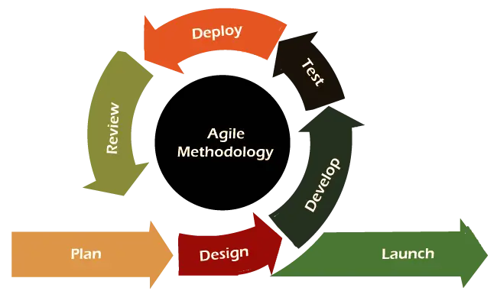

**1>Process Modeling:**

Process modeling plays a crucial role in the development of CollegeWeb. We create detailed process flow diagrams to map out the user journey for both colleges and students within the platform. This includes activities like user registration, college profile creation, course-based college search, and the review system. Process modeling helps us identify potential bottlenecks, optimize workflows, and ensure a seamless and intuitive user experience.

**2>Requirements Gathering and Analysis:**

Thorough requirements gathering and analysis are conducted at the outset of the project. We engage in discussions with stakeholders and potential users, to understand their needs, pain points, and desired features. These requirements are documented, refined, and prioritized to establish a clear roadmap for the development process.

**3>Design and Prototyping:**

Following the requirements gathering phase, we proceed with designing the user interface (UI) and user experience (UX) of CollegeWeb. Interactive prototypes are created to visualize the layout, navigation, and functionalities of the platform. This iterative process involves feedback from stakeholders to ensure that the final design aligns with their expectations and needs.

**4>Development and Testing:**

The development phase encompasses building the core functionalities of CollegeWeb. Our team adheres to best practices, writes clean and maintainable code, and conducts regular code reviews to ensure high-quality software. Concurrently, rigorous testing procedures, including unit testing, integration testing, and user acceptance testing (UAT), are carried out to identify and resolve any issues or bugs promptly.

**5>Deployment and User Training:**

Upon successful development and testing, CollegeWeb is deployed to a staging environment for final evaluation before production deployment. User training materials and documentation are prepared to facilitate the onboarding process for colleges and students. The system's performance and security are assessed, and necessary measures are taken to ensure a smooth and secure deployment.

**6>Maintenance and Iterative Enhancements:**

Post-deployment, we closely monitor the platform's performance, address any potential issues, and provide ongoing support to users. Regular updates and iterative enhancements are planned based on user feedback and evolving requirements to ensure CollegeWeb remains a valuable and dynamic solution for colleges and students.

**Design**

**Use Case Diagram**

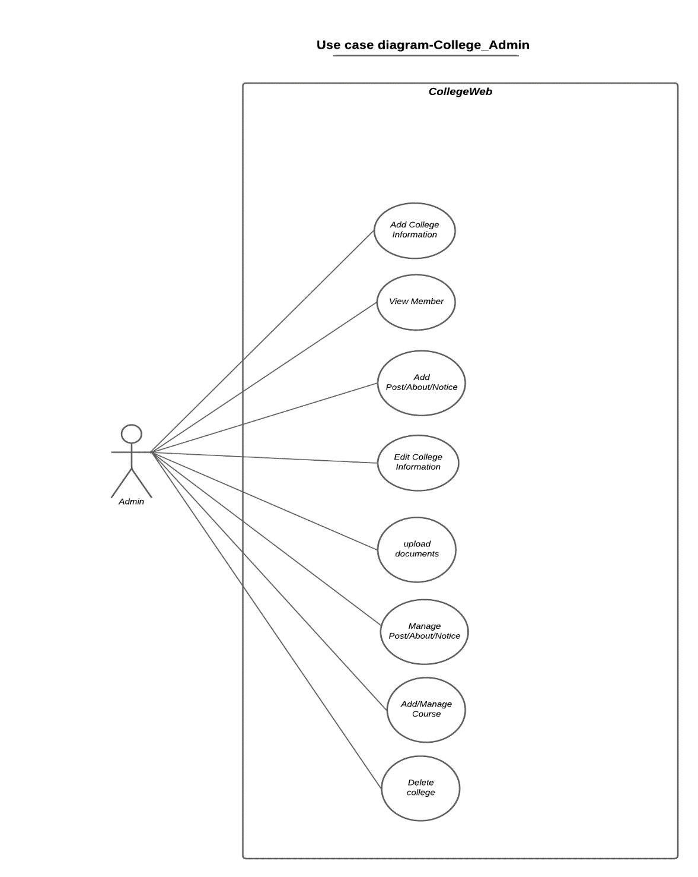

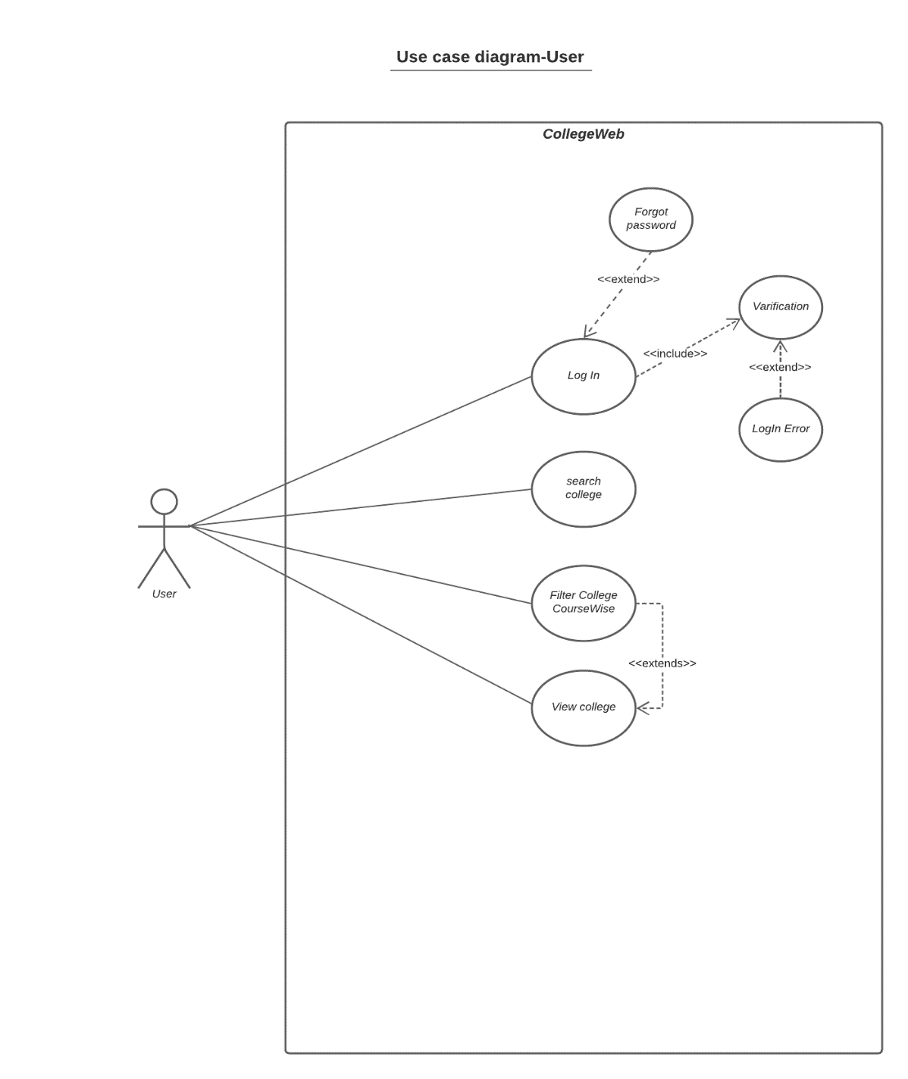

Use Case Diagram Logged In User

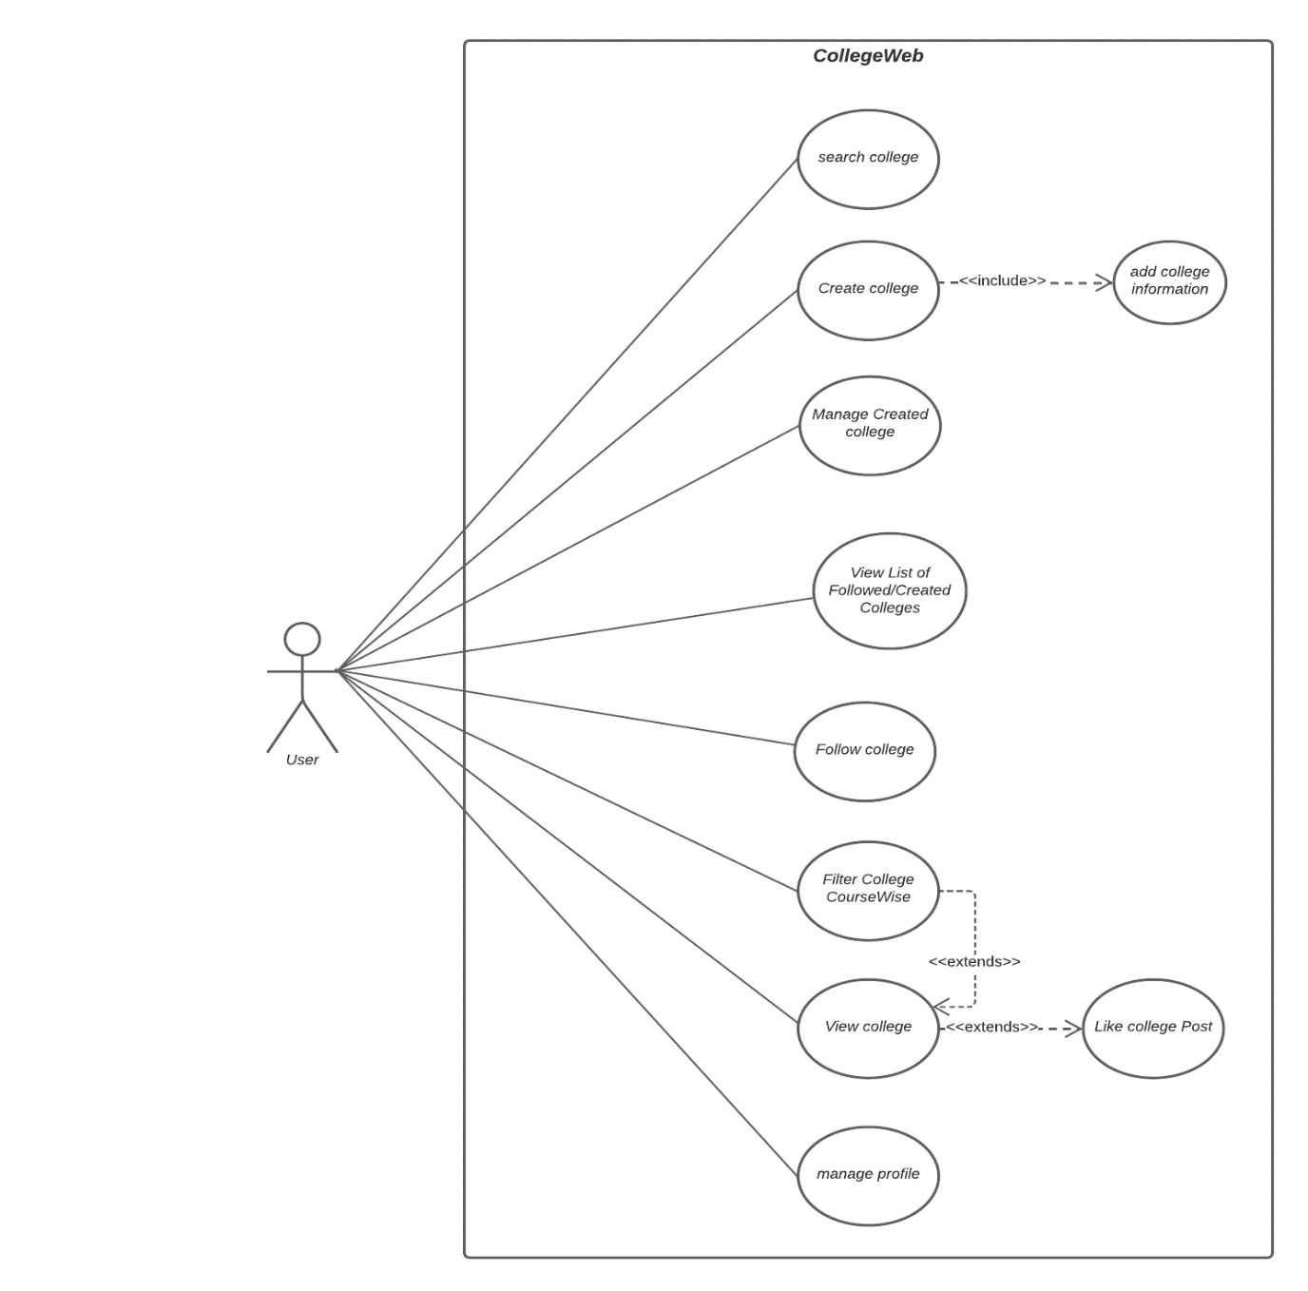

**Class Diagram** 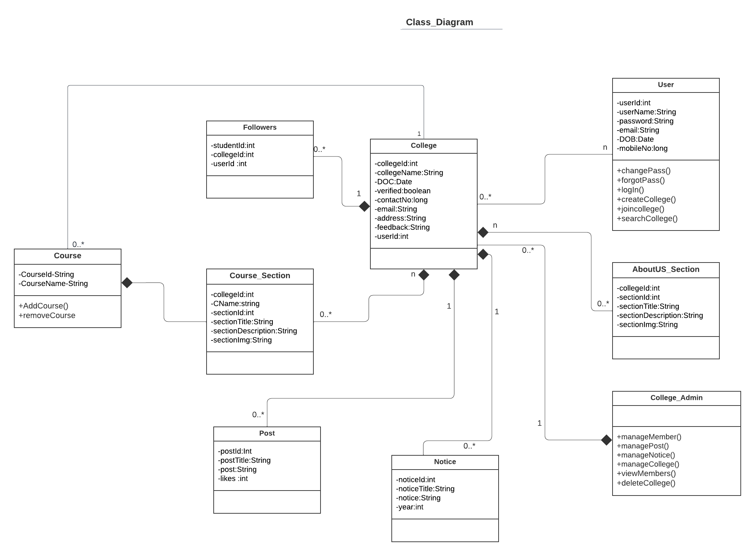

**Activity Diagram**

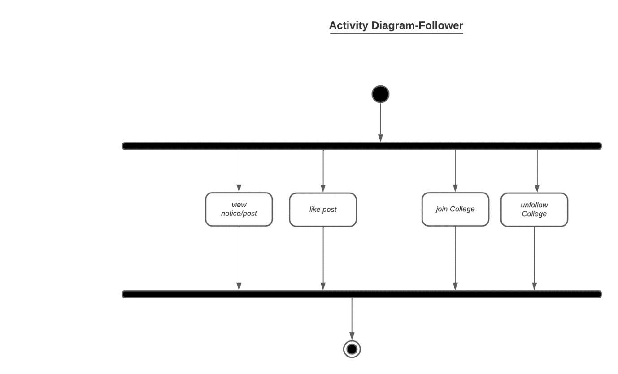

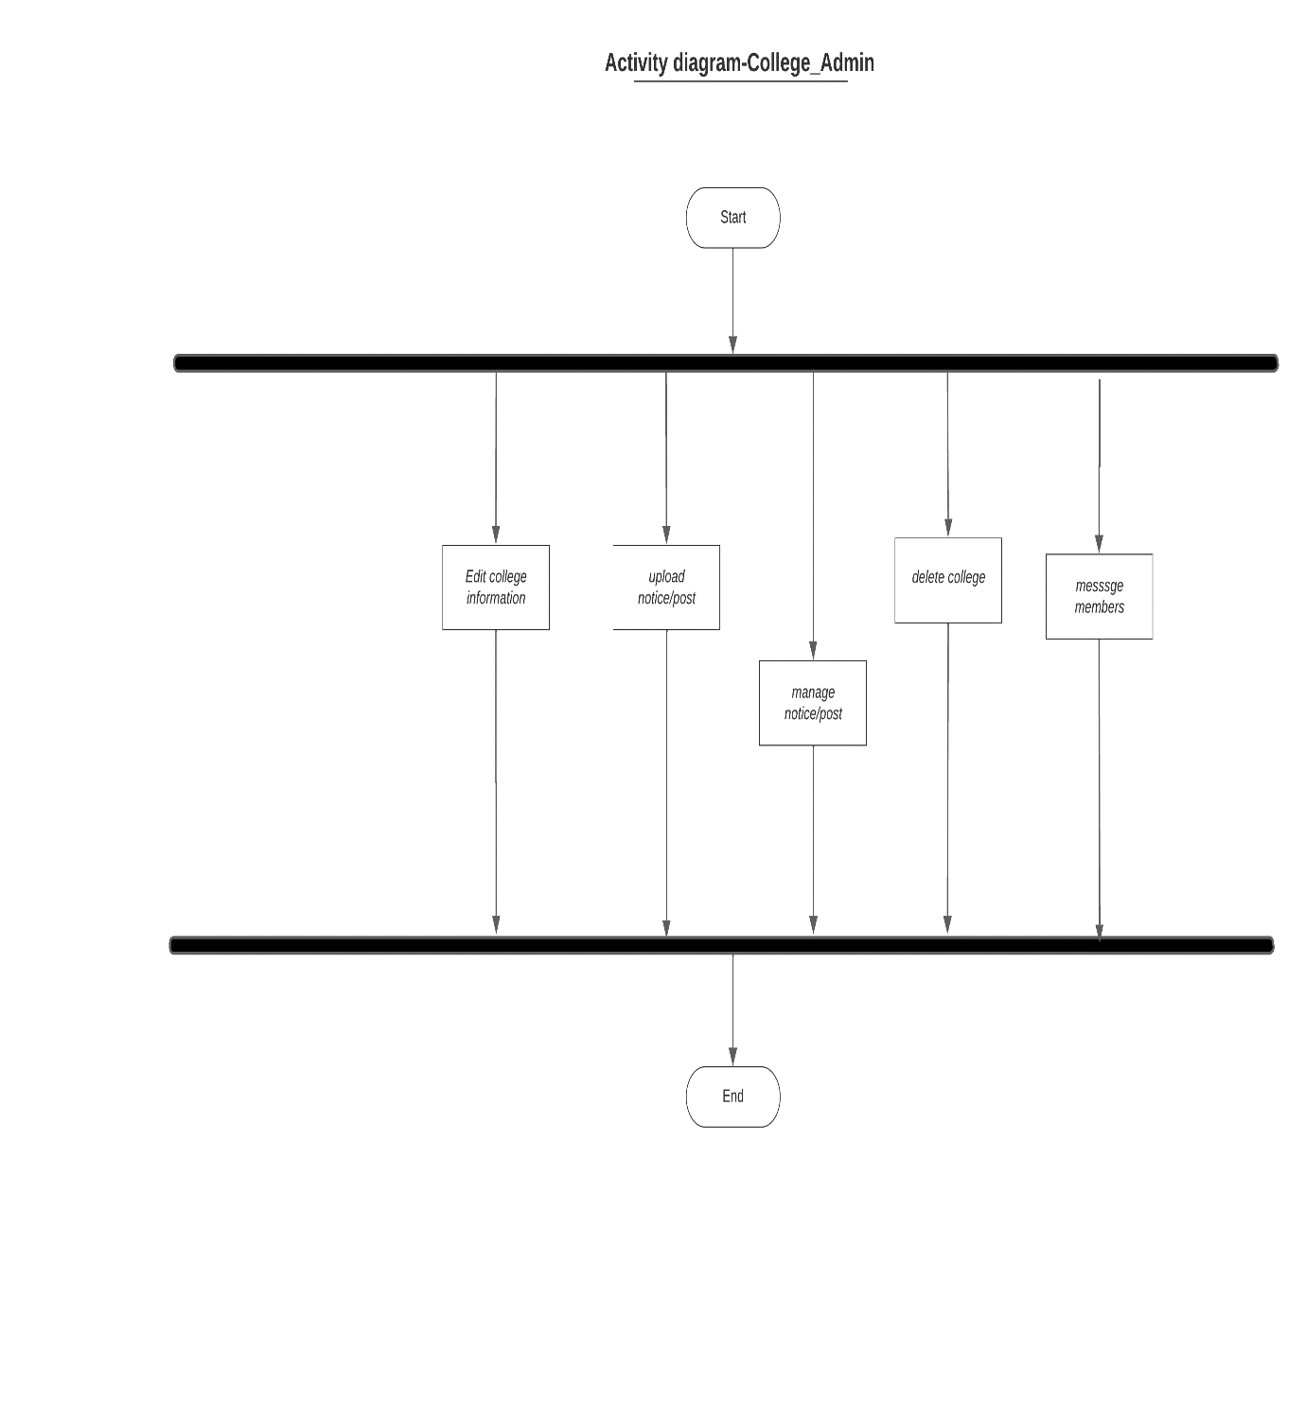

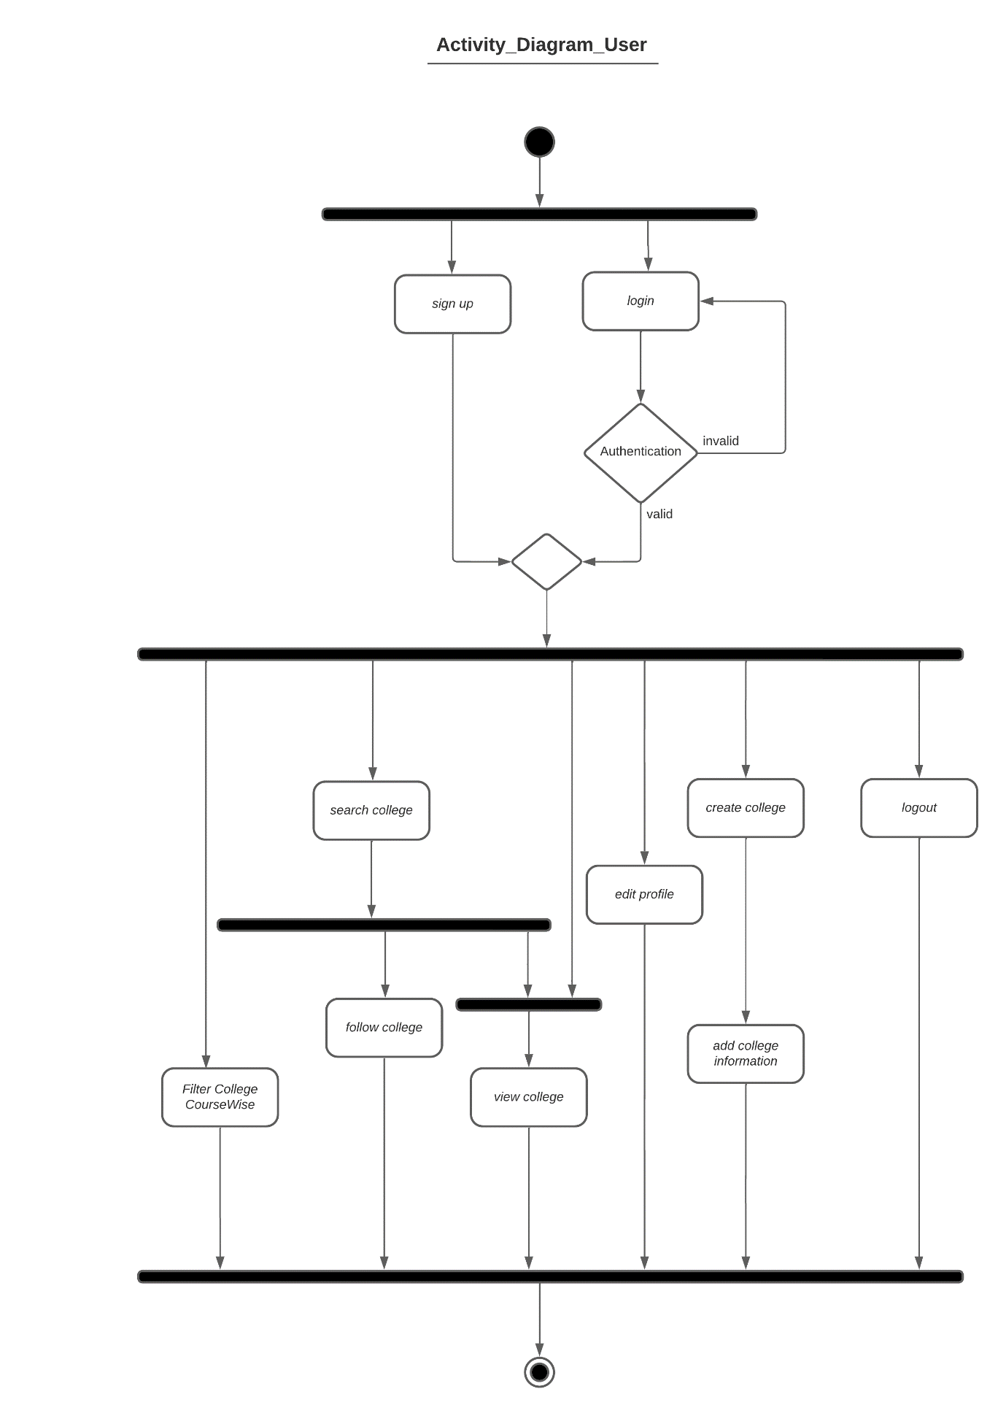

**Sequence Diagram**

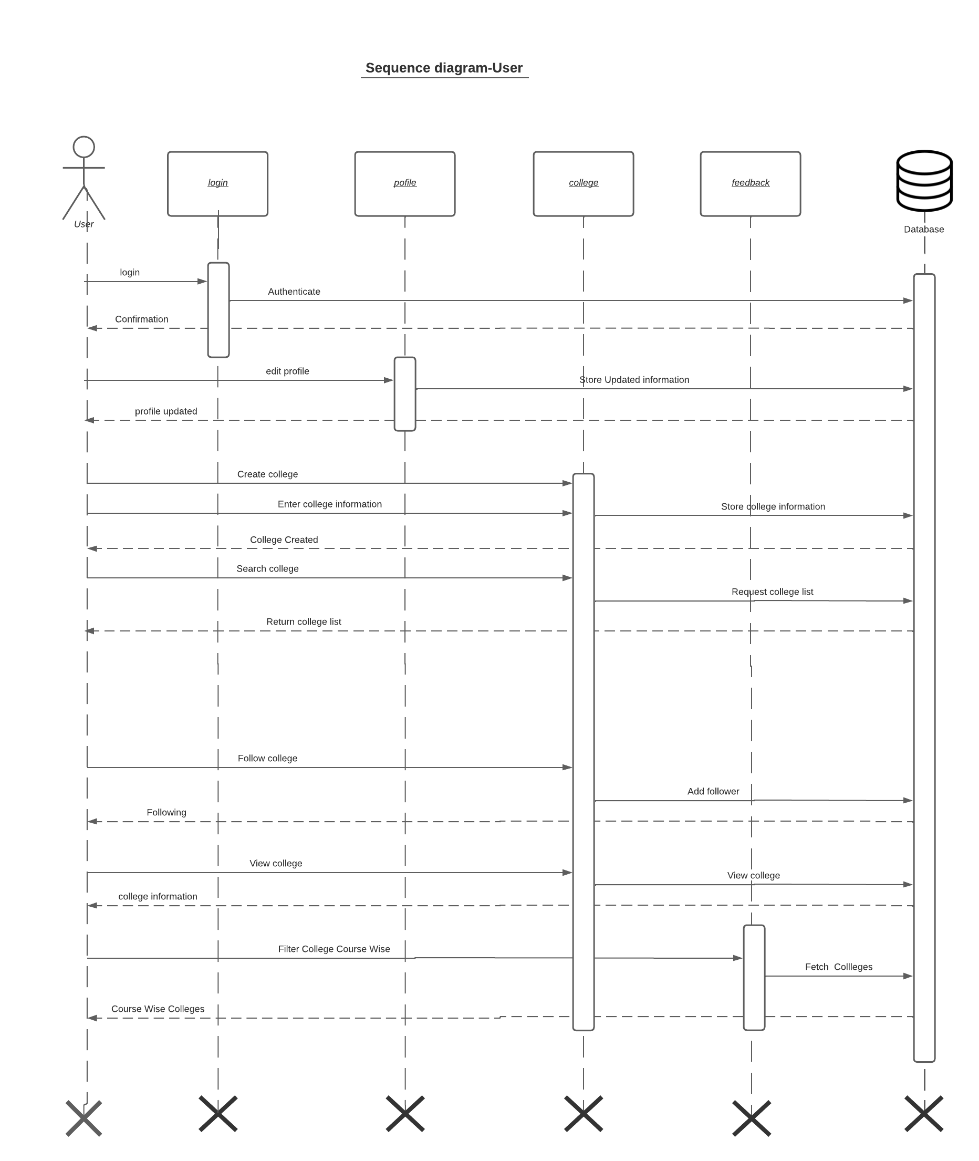

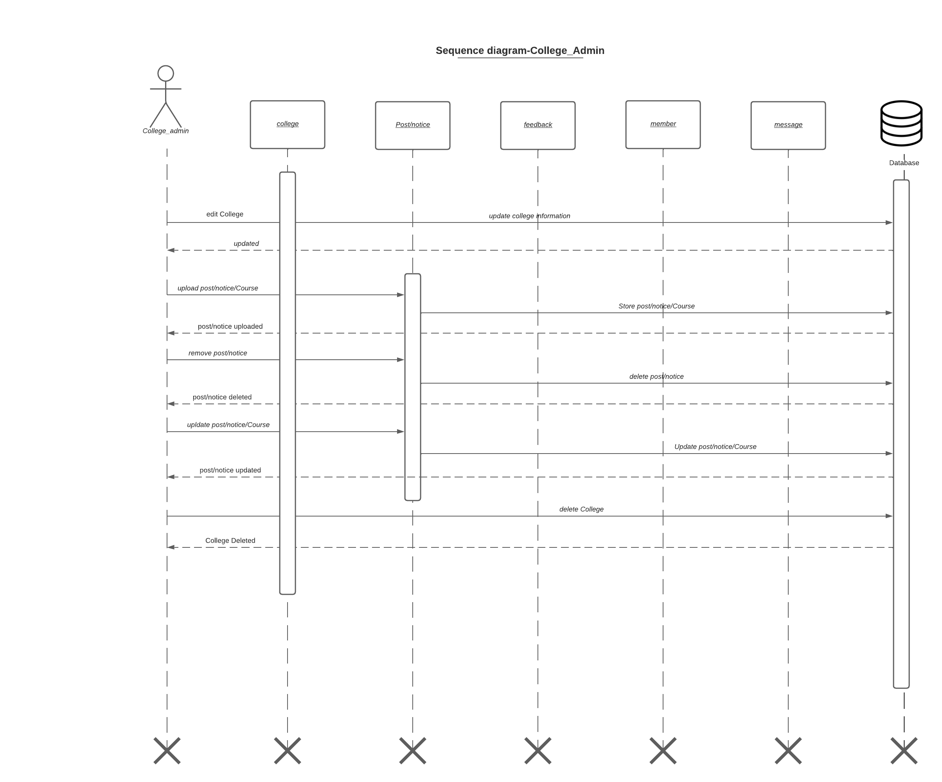

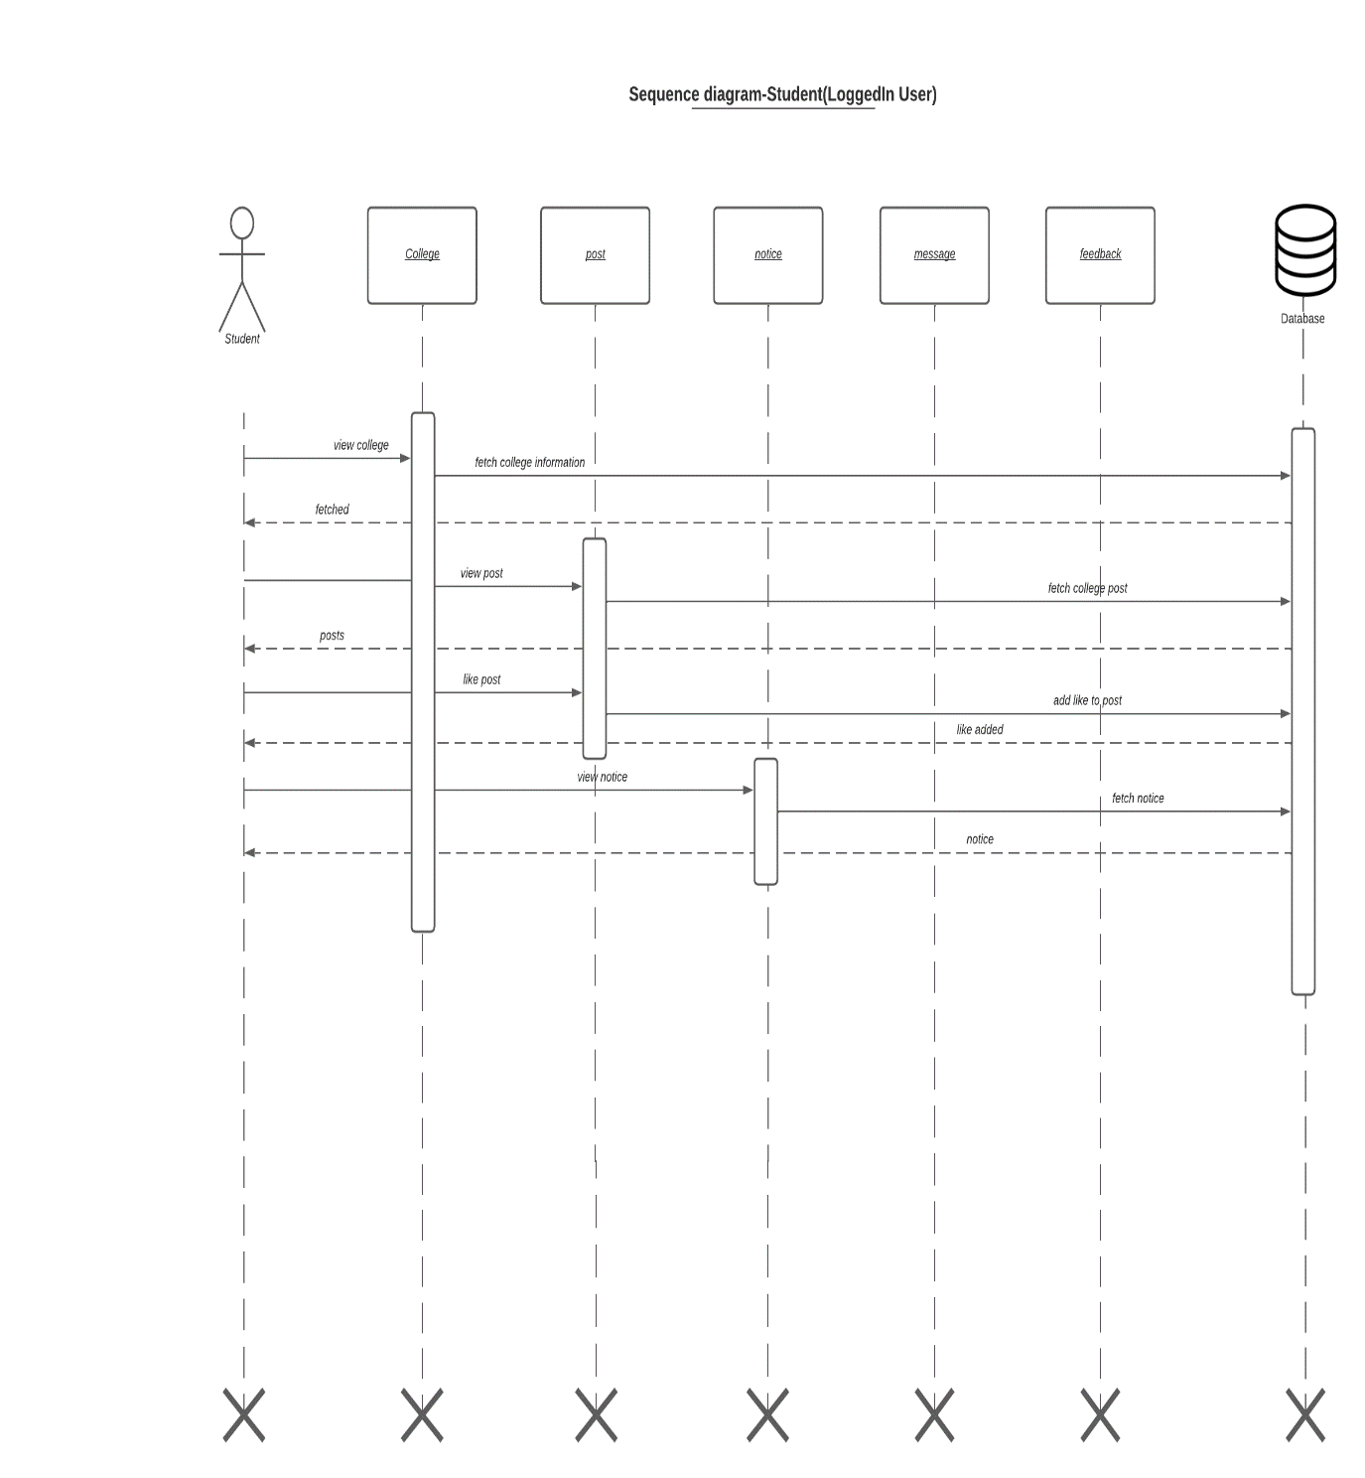

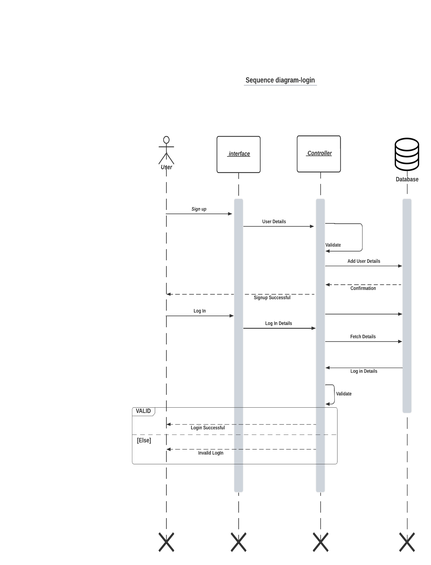

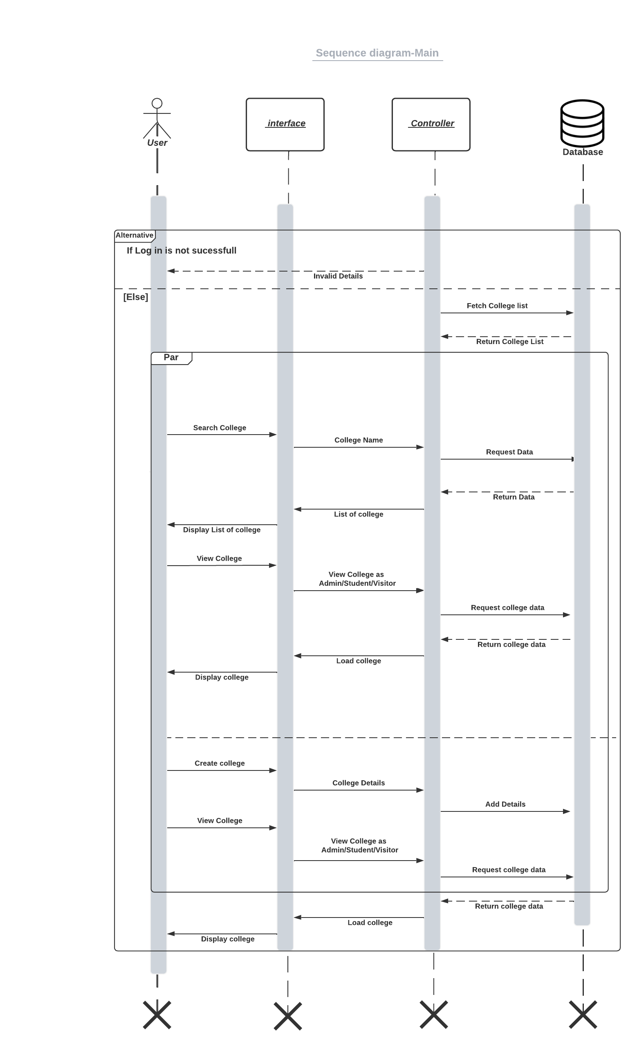

**System Flow Diagram**

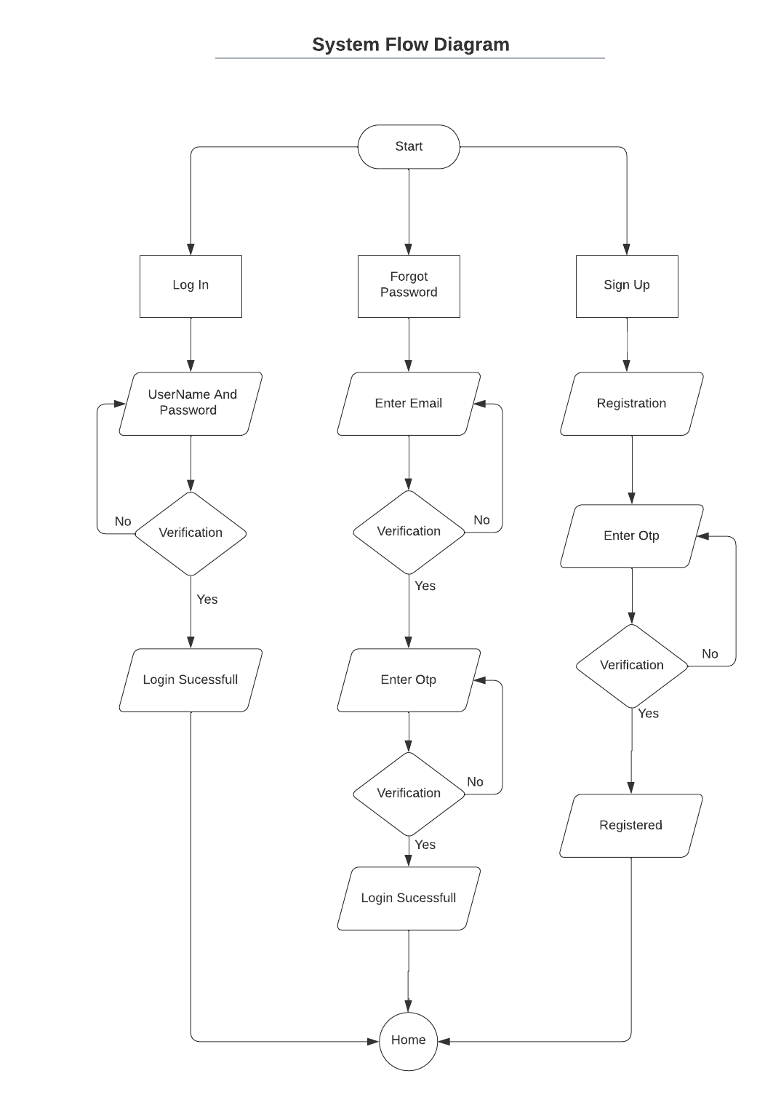

**System Navigation**

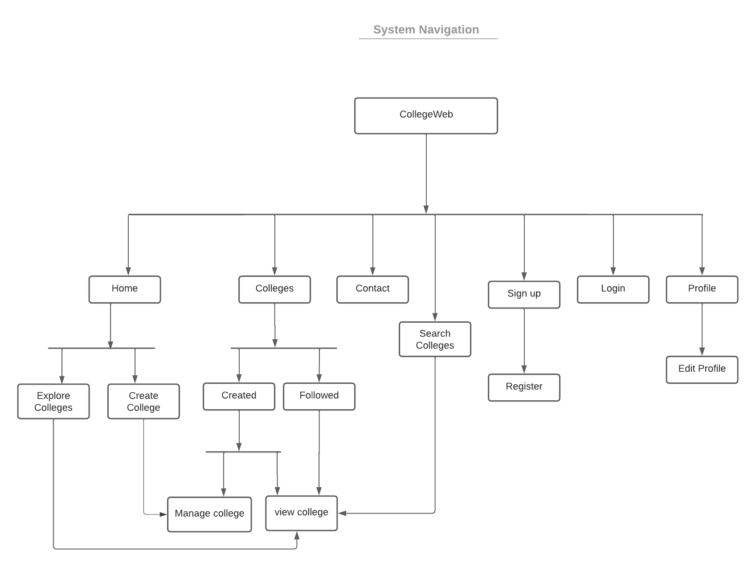

**Snapshots**

**Home Screen**



**HomeScreen2**

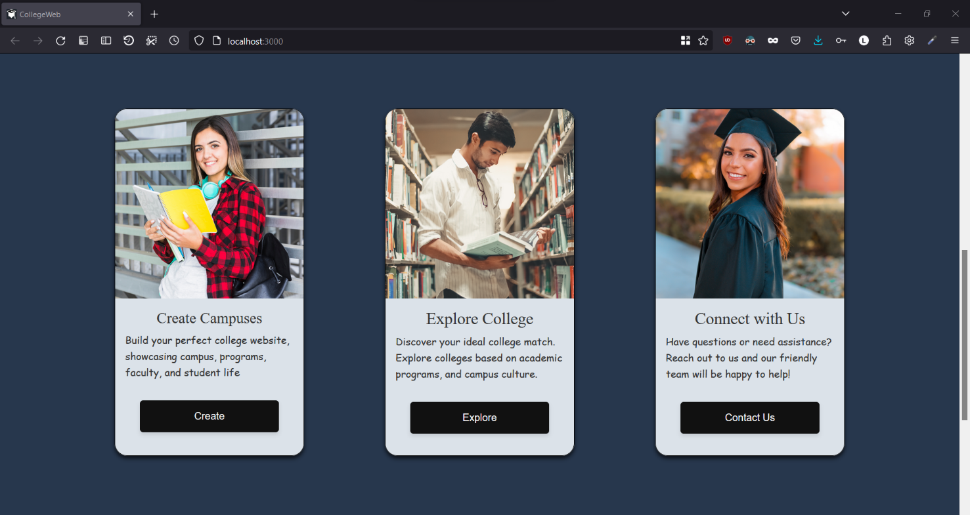

**Footer**

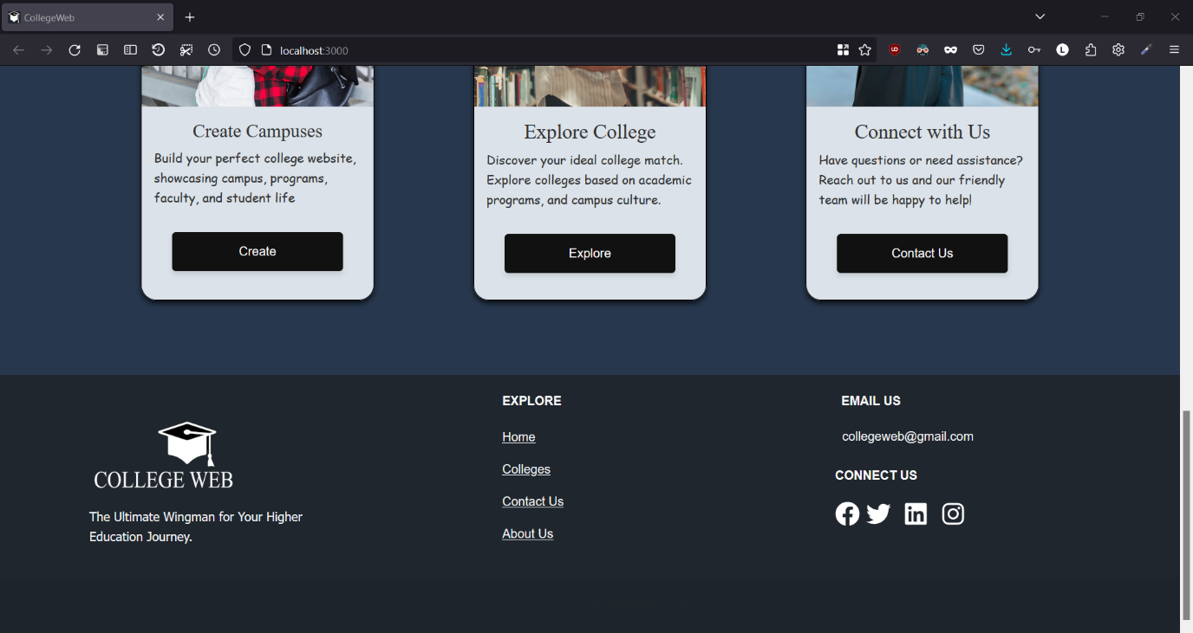

**Create College About Us**

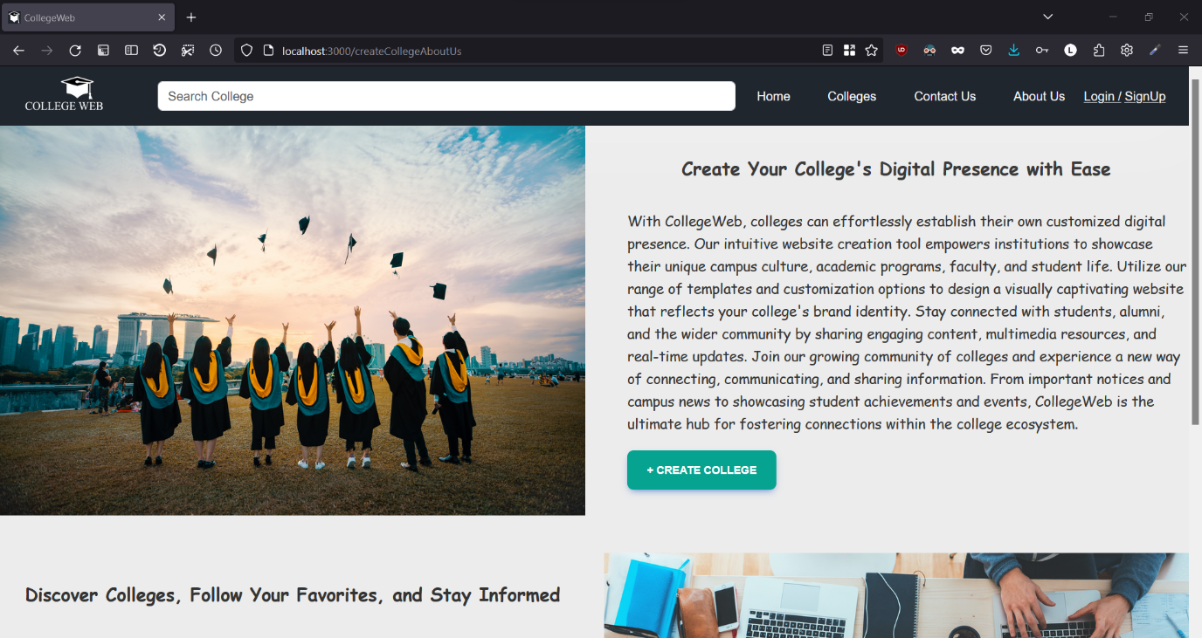

**Create College About Us 2**

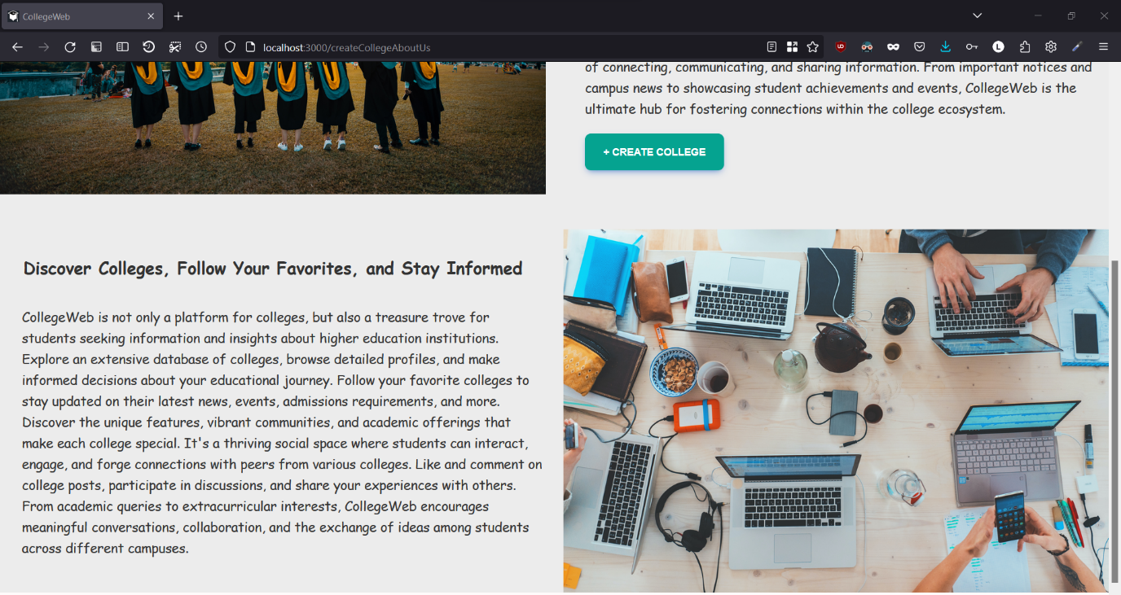

**Contact Us**

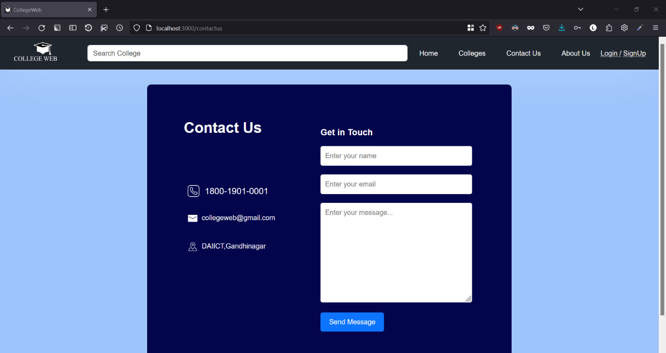

**Explore College**

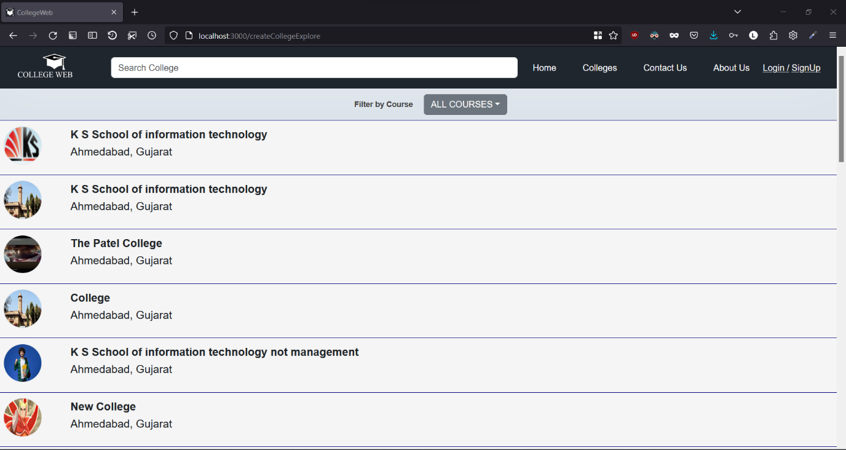

**Filter By Course**

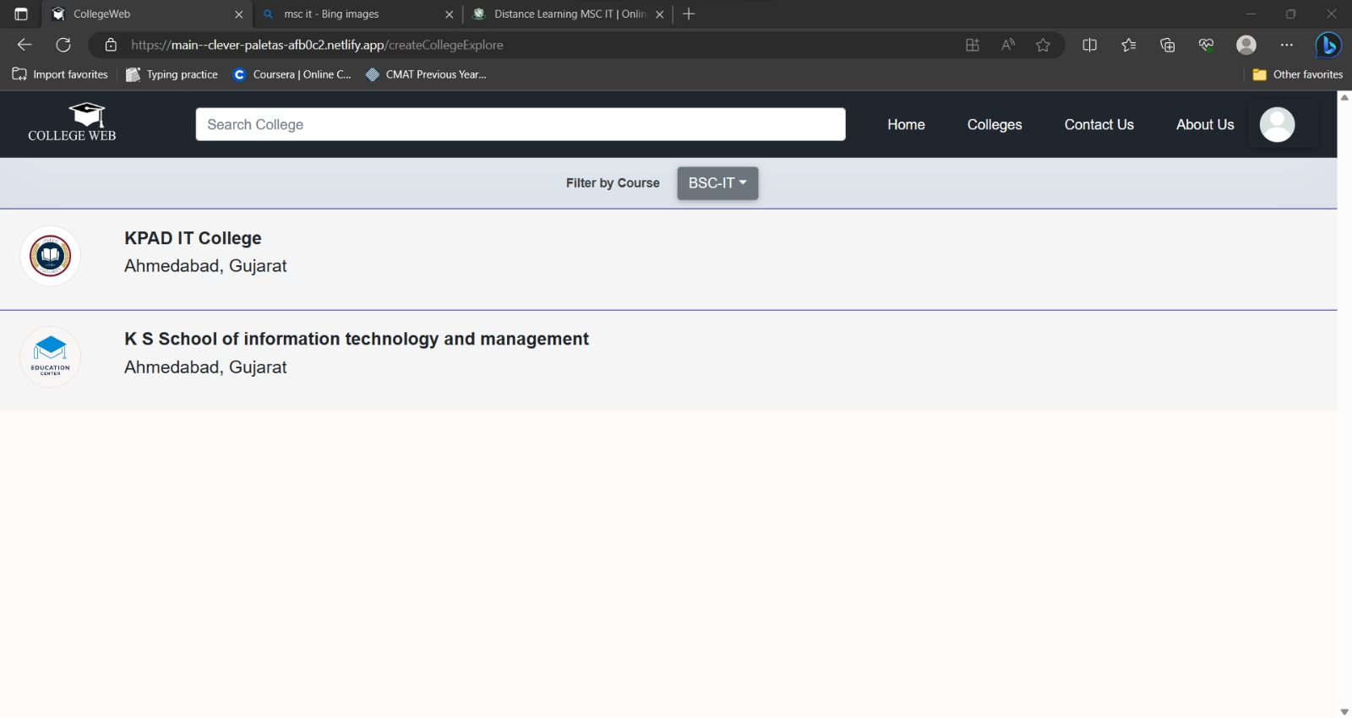

**About Us**

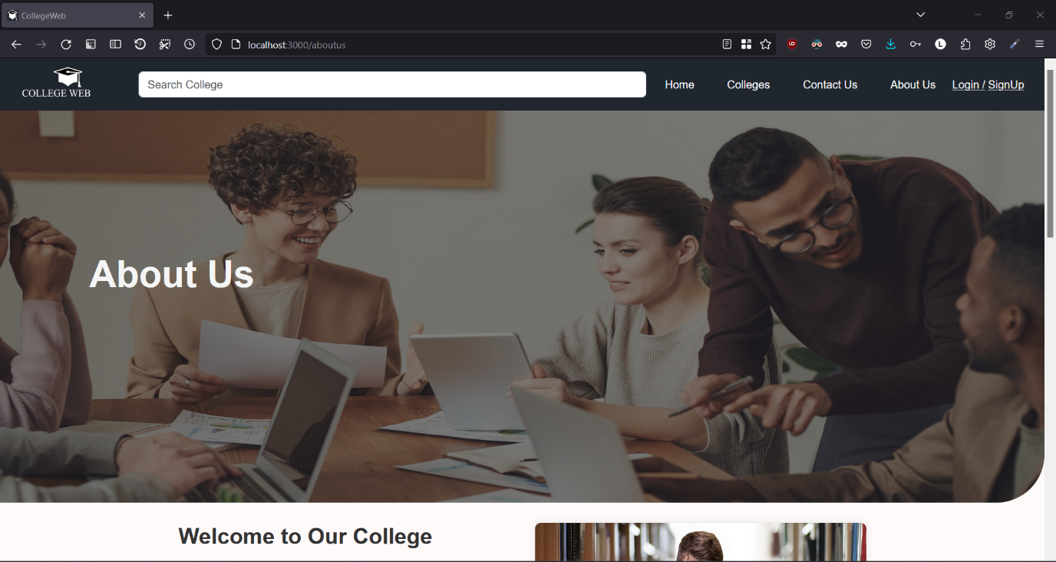

**About Us 2**

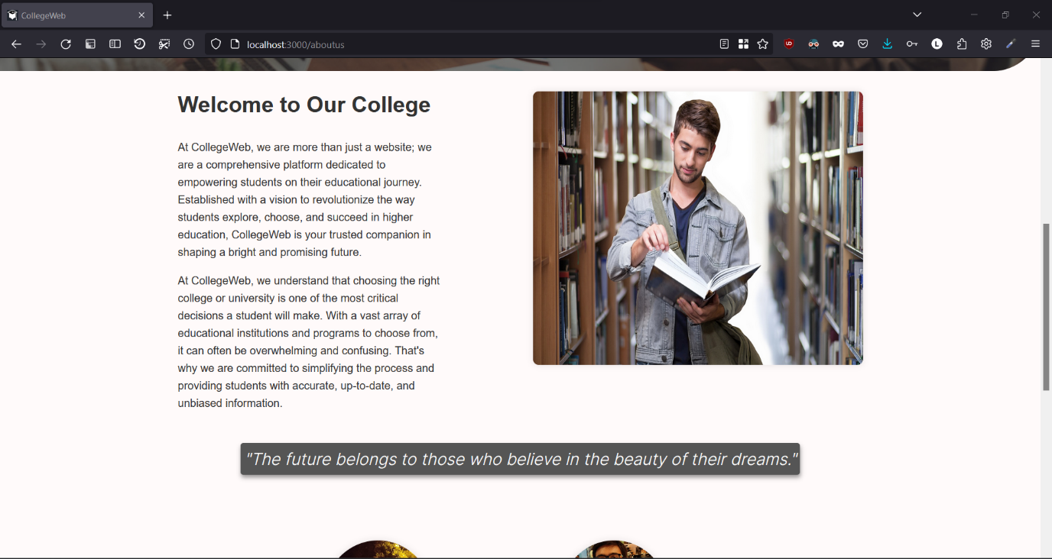

**About Us 3**

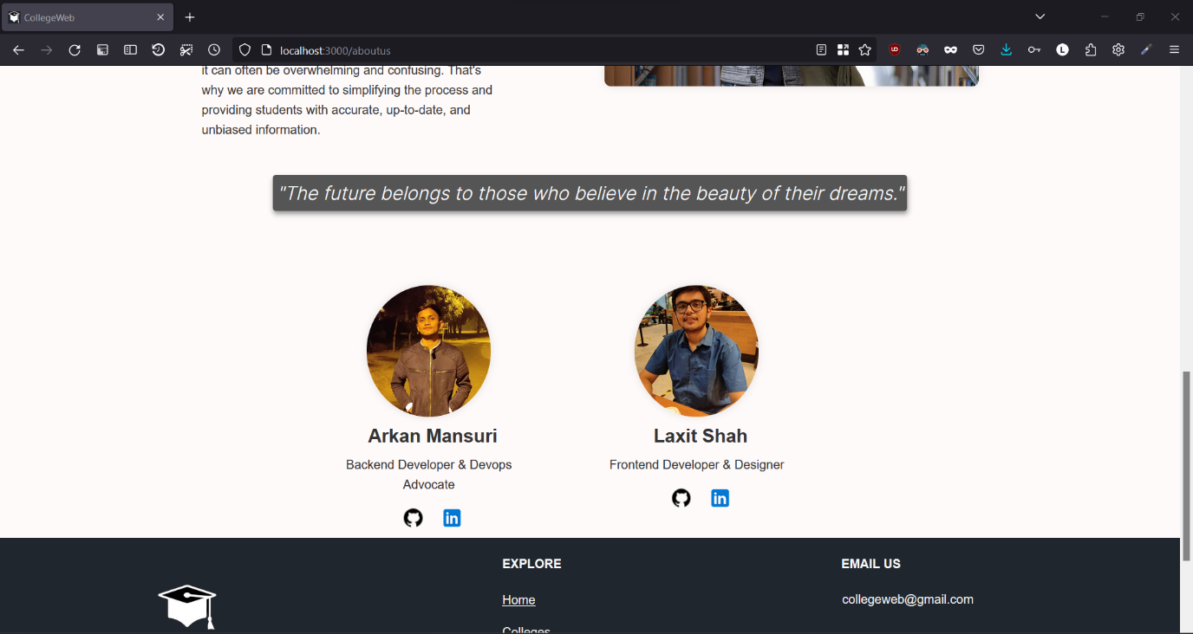

**Sign Up**

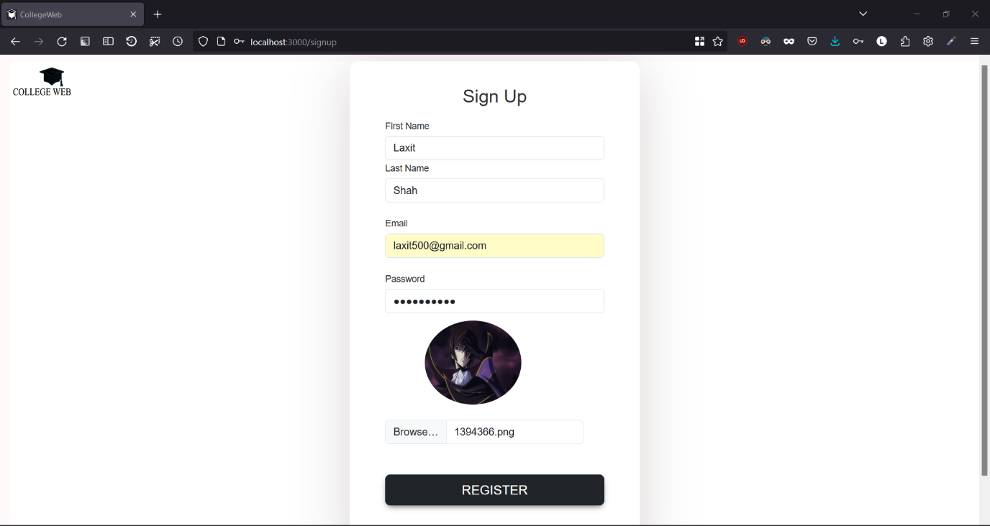

**Mail**

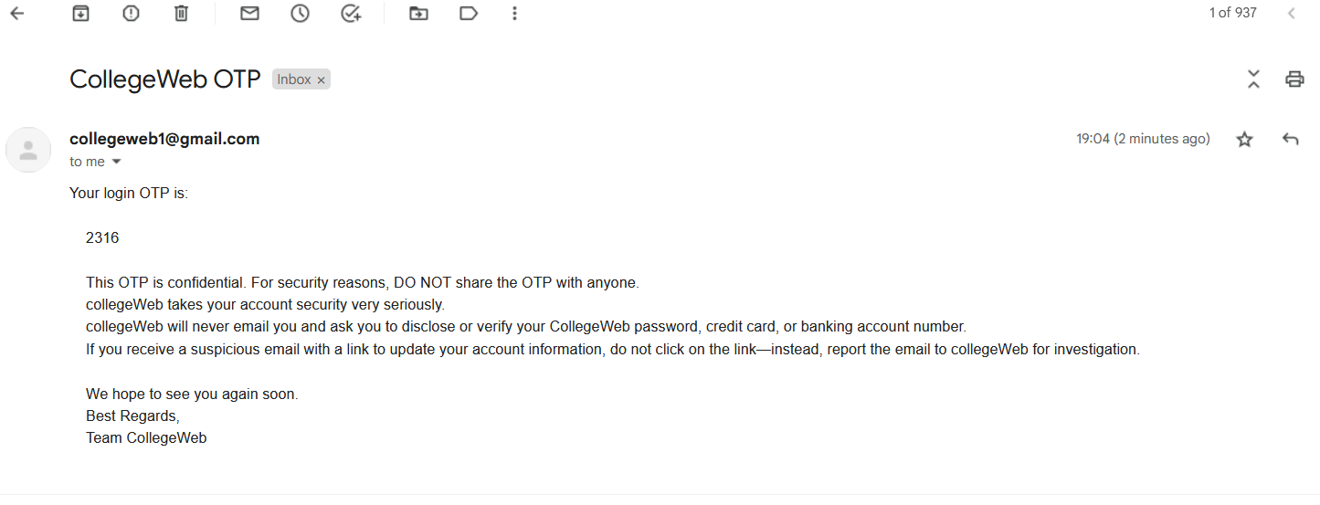

**OTP Page**

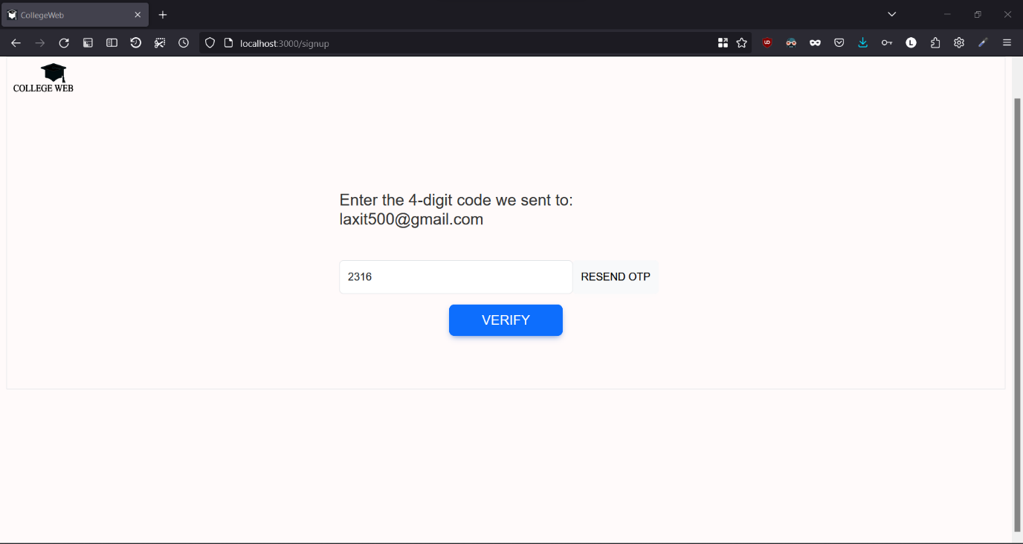

**Login Page**

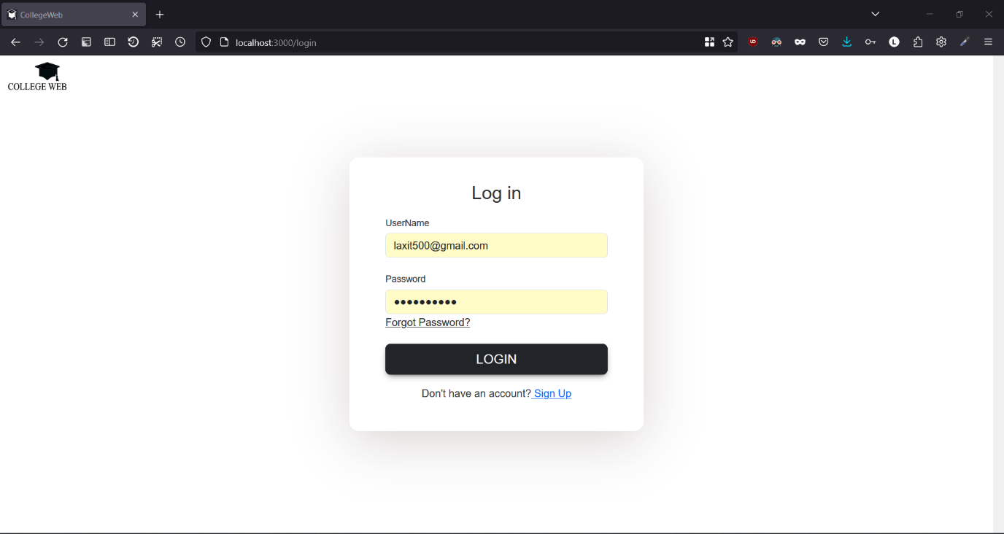

**Forgot Password**

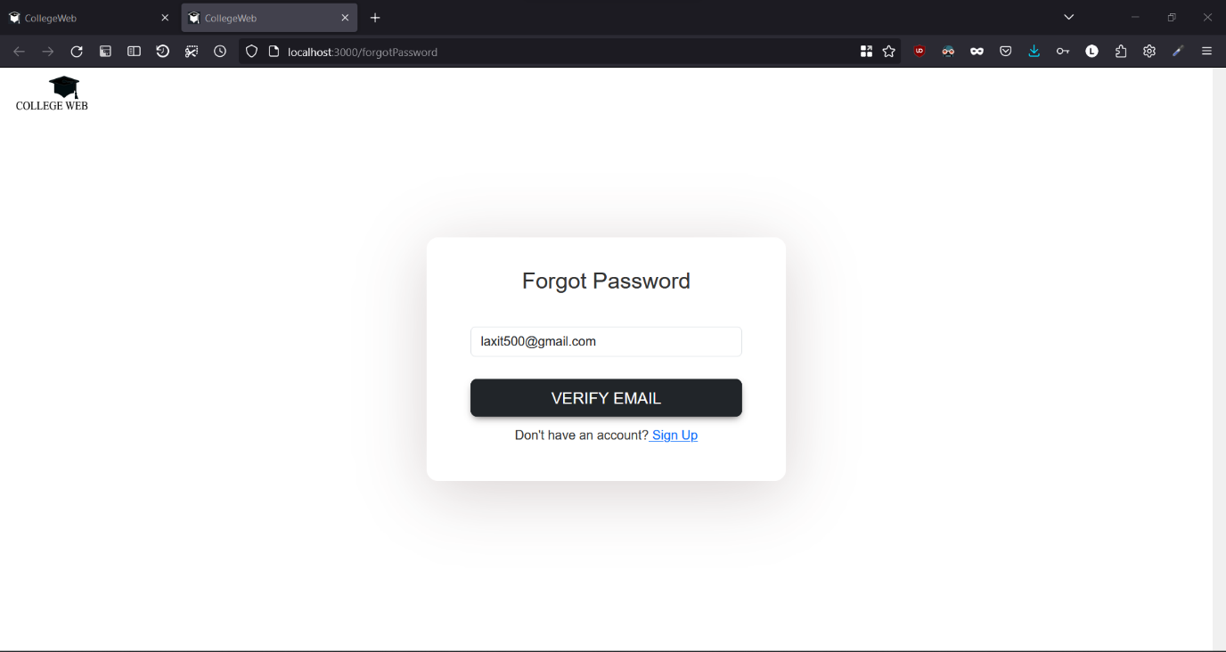

**Home Screen After Login**

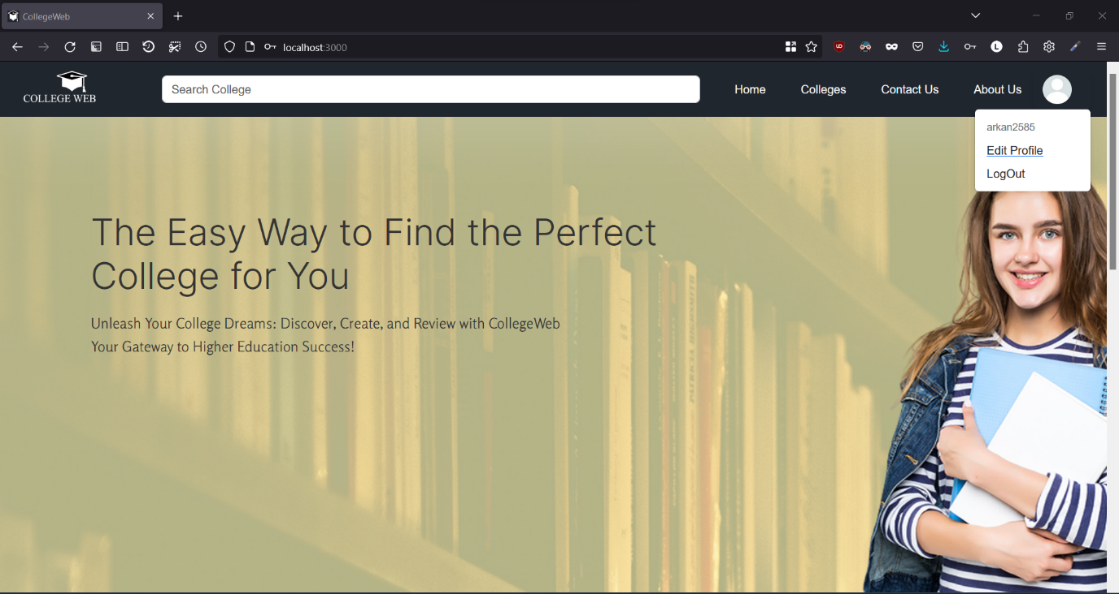

**Followed College**

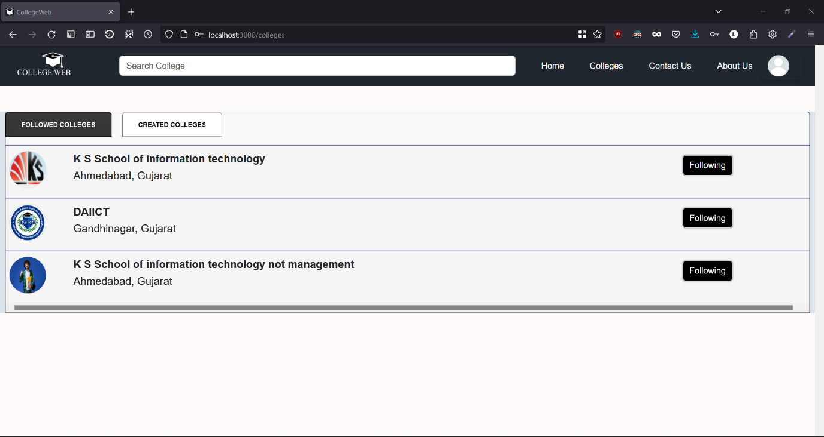

**Create College Page**

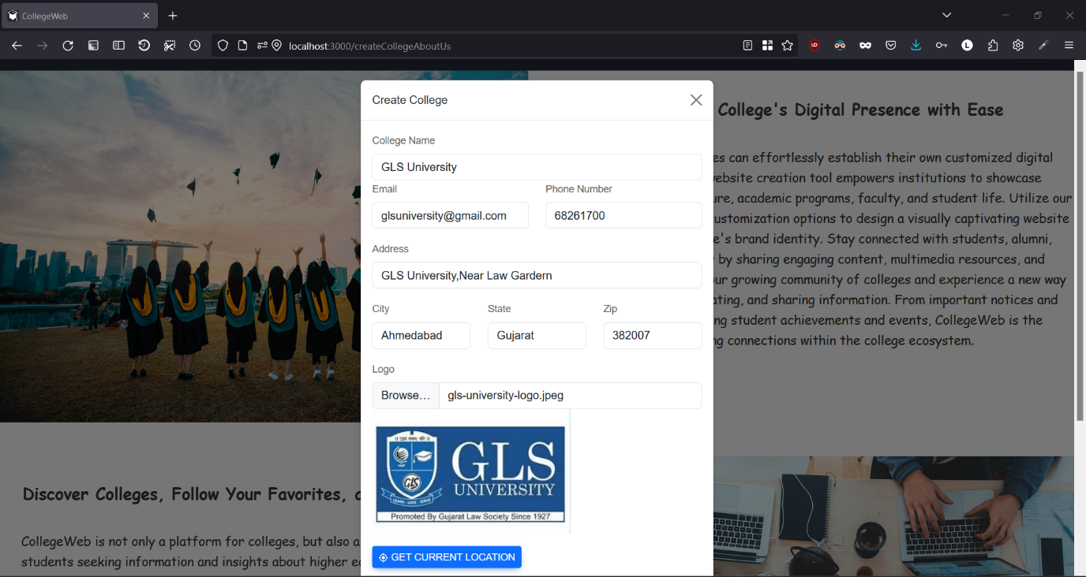

**Create College Location  
  
  
  
  
  
  
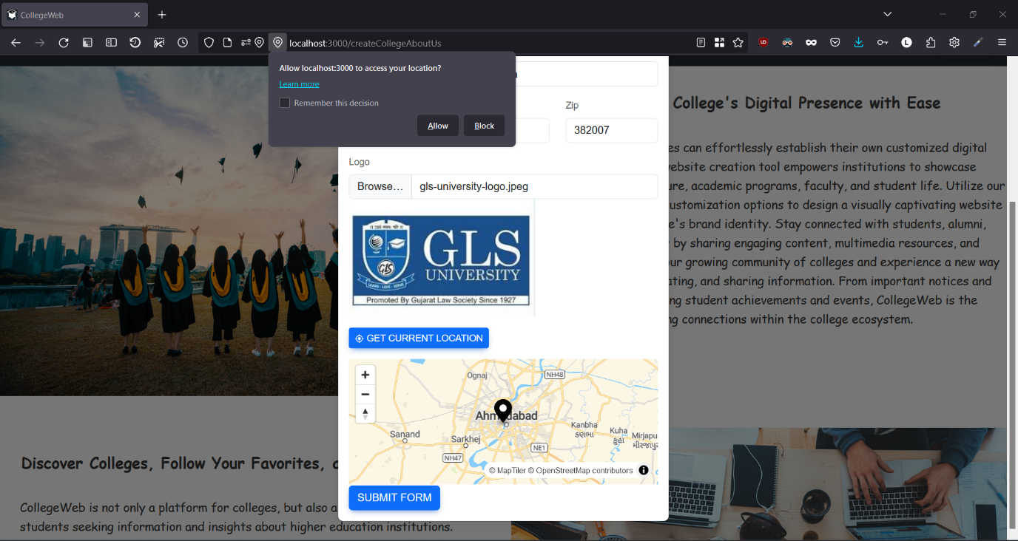**

**Create College Location 2**

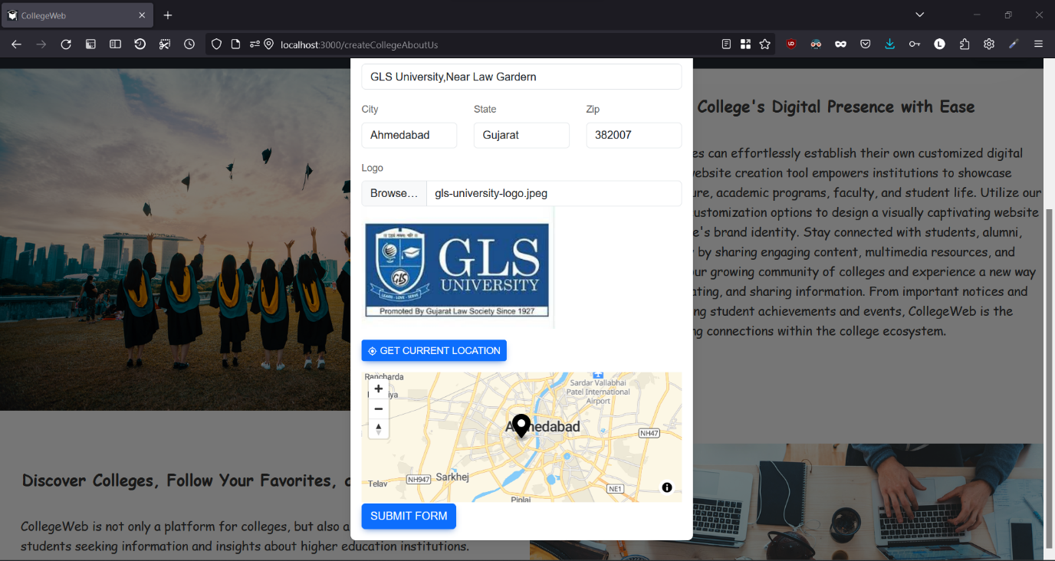

**Responsive**

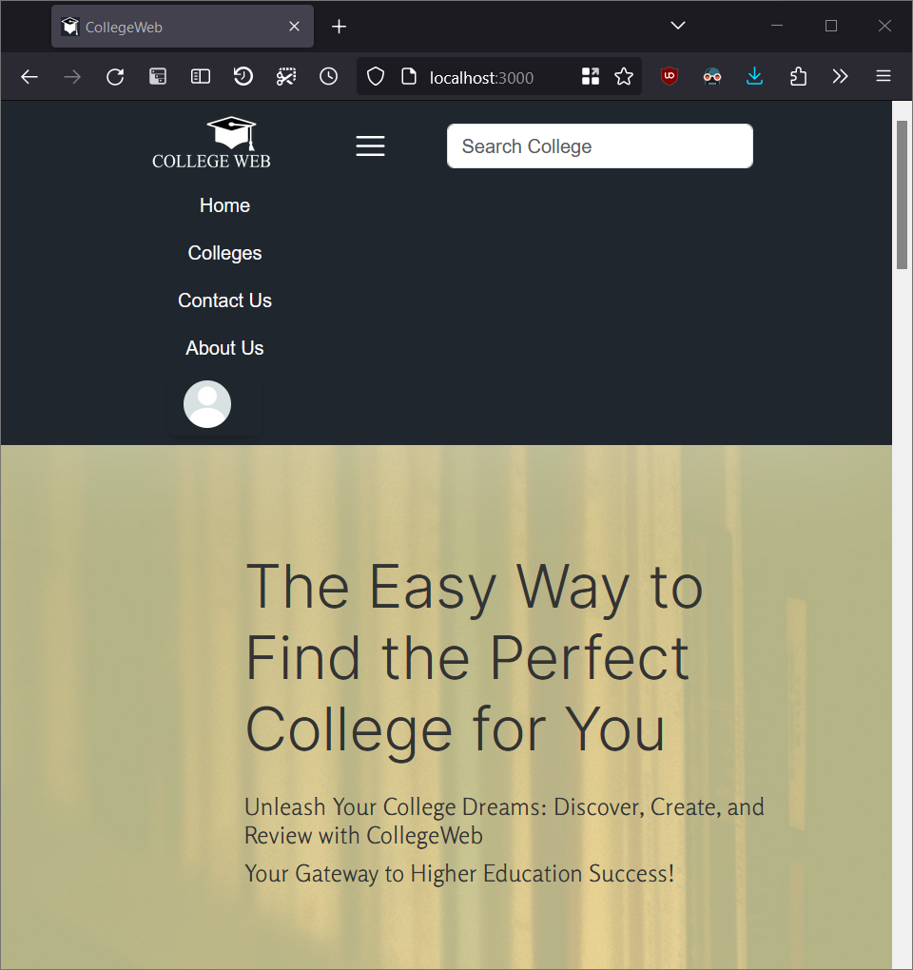

**Responsive 2**

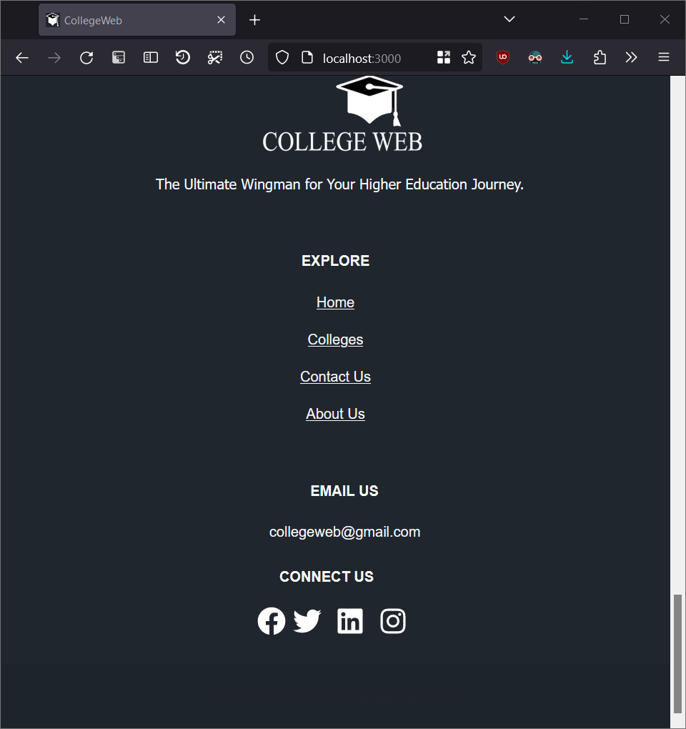

**College Admin View Home**

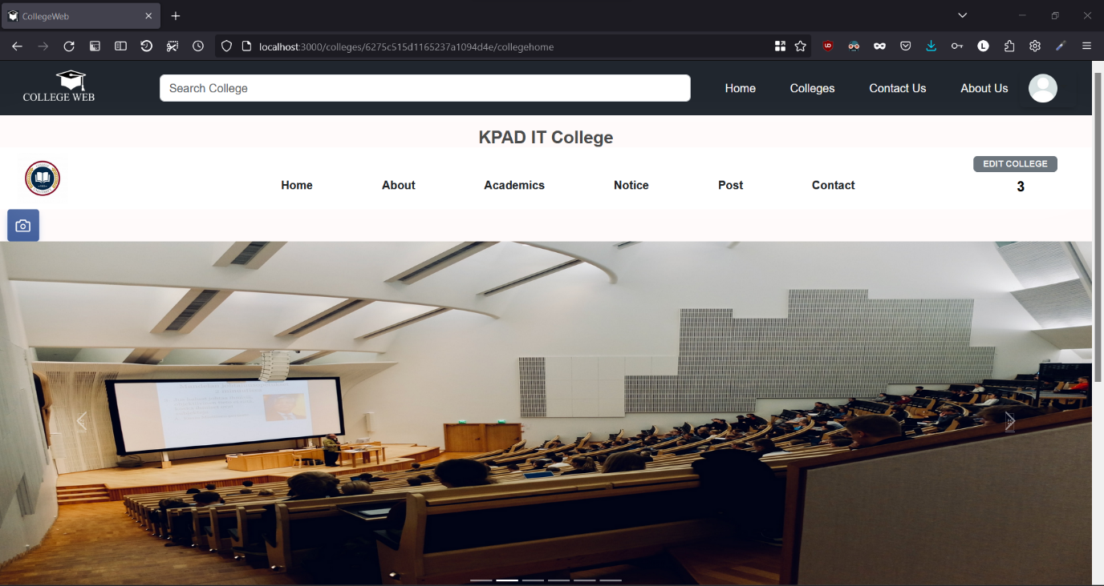

**College Admin View Home 2**

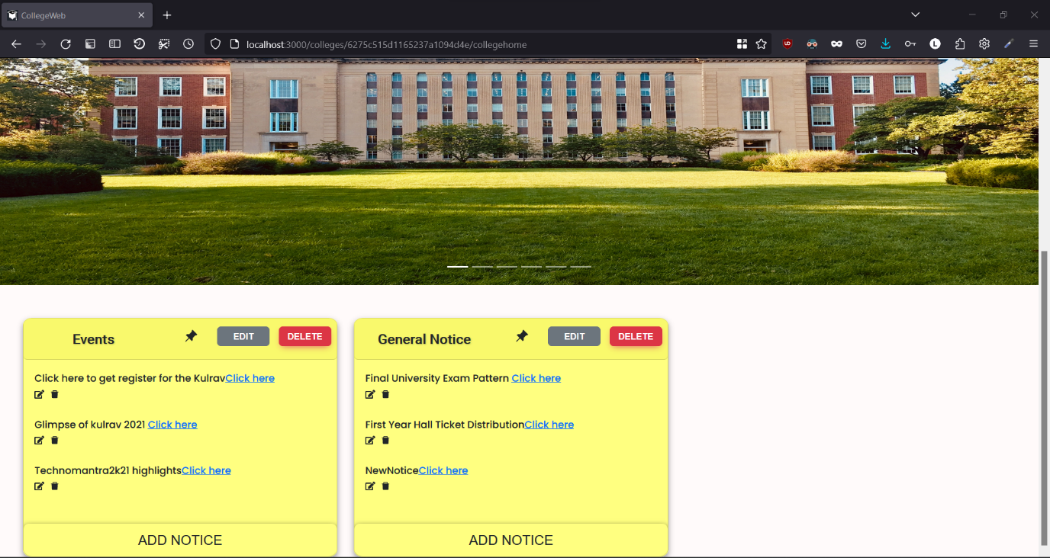

**College Add Images View**

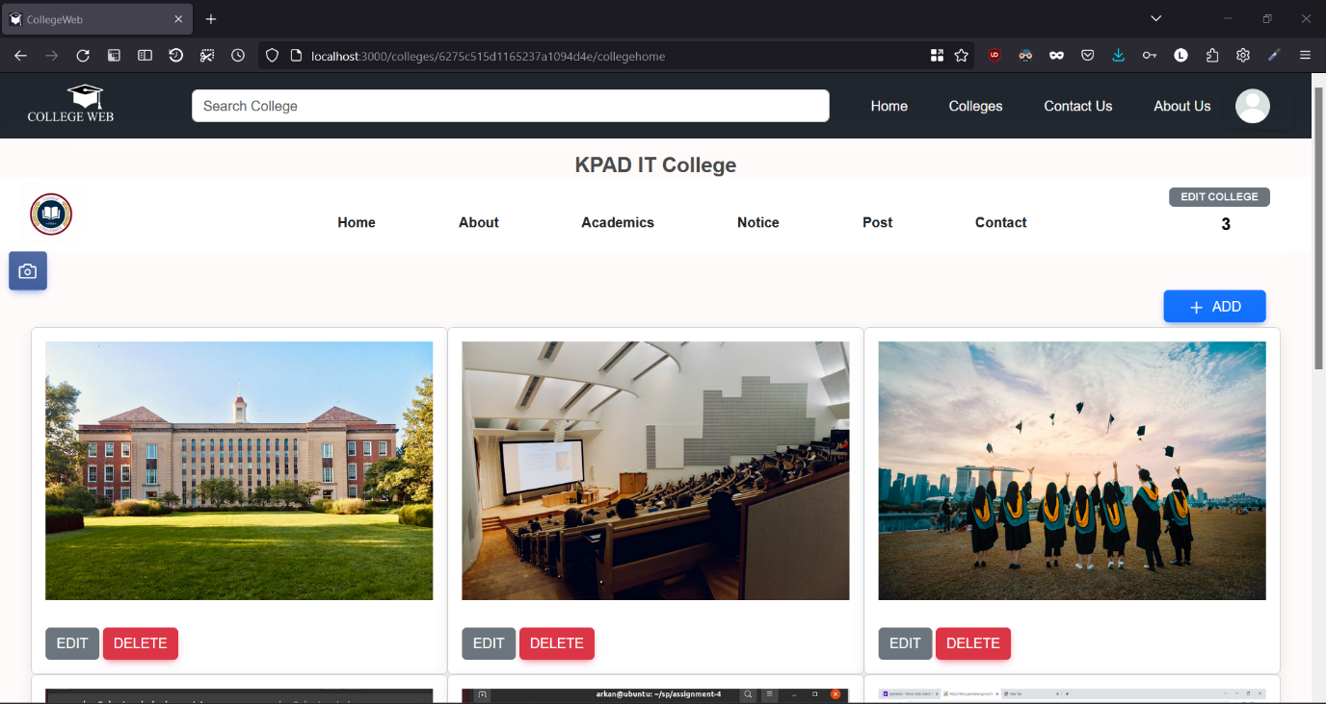

**College About Us**

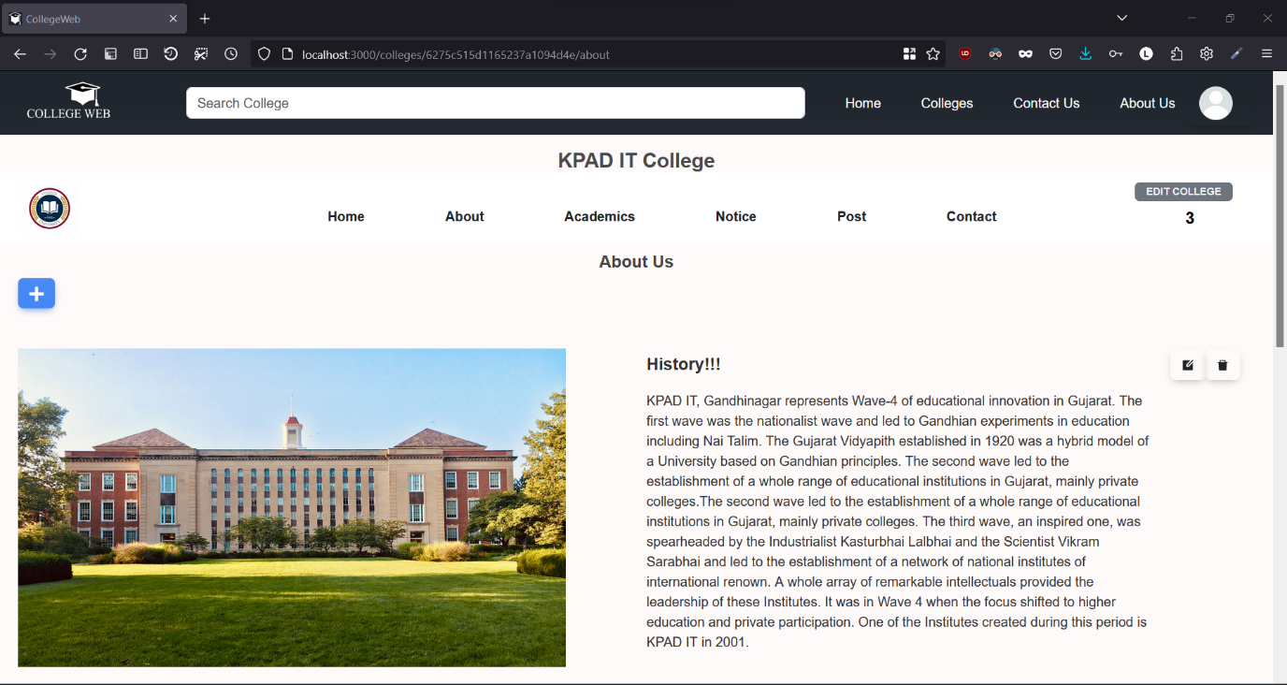

**College About Us Edit**

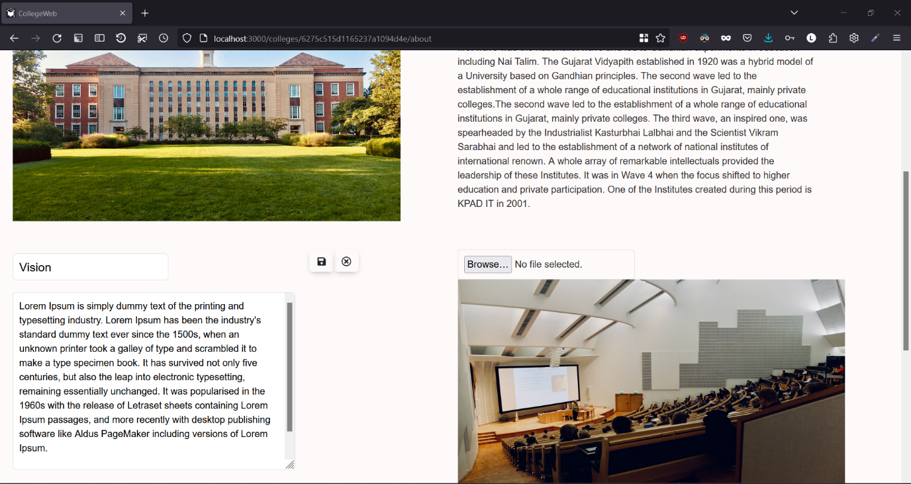

**Edit College Details**

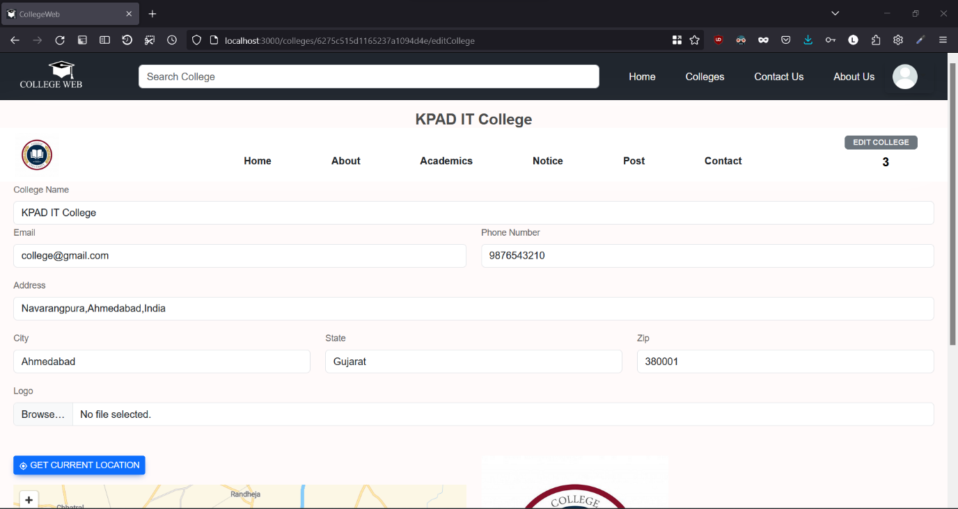

**Edit College Details 2**

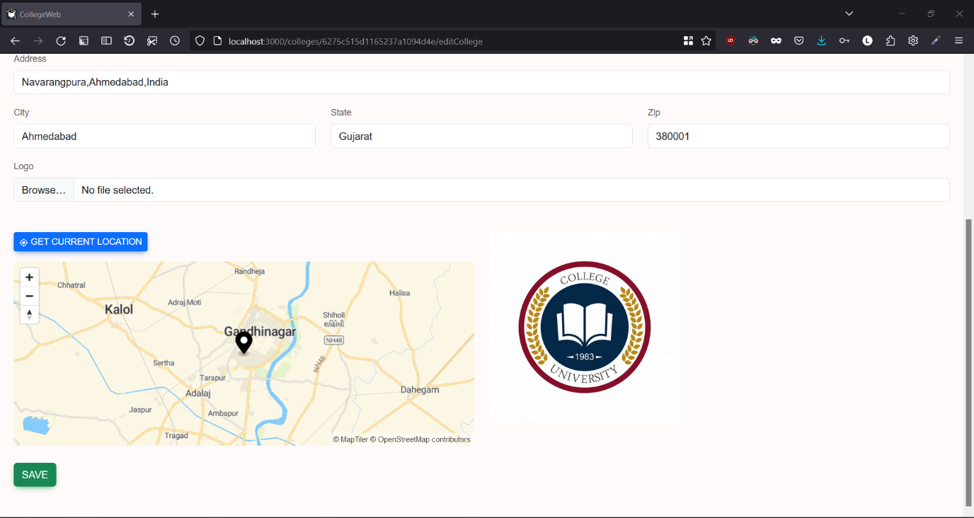

**College Academics**

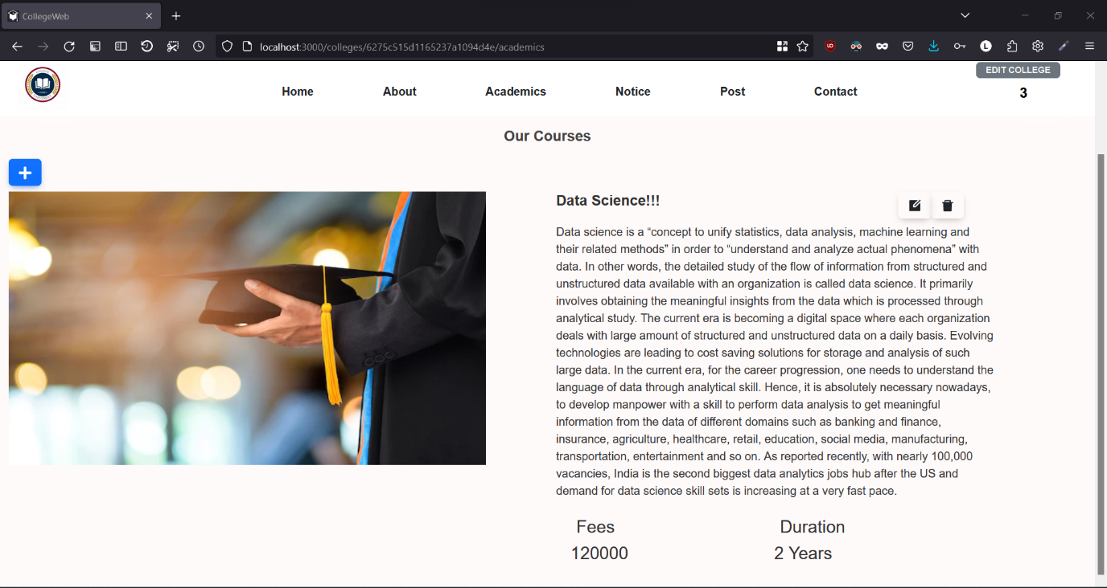

**College Academics Edit**

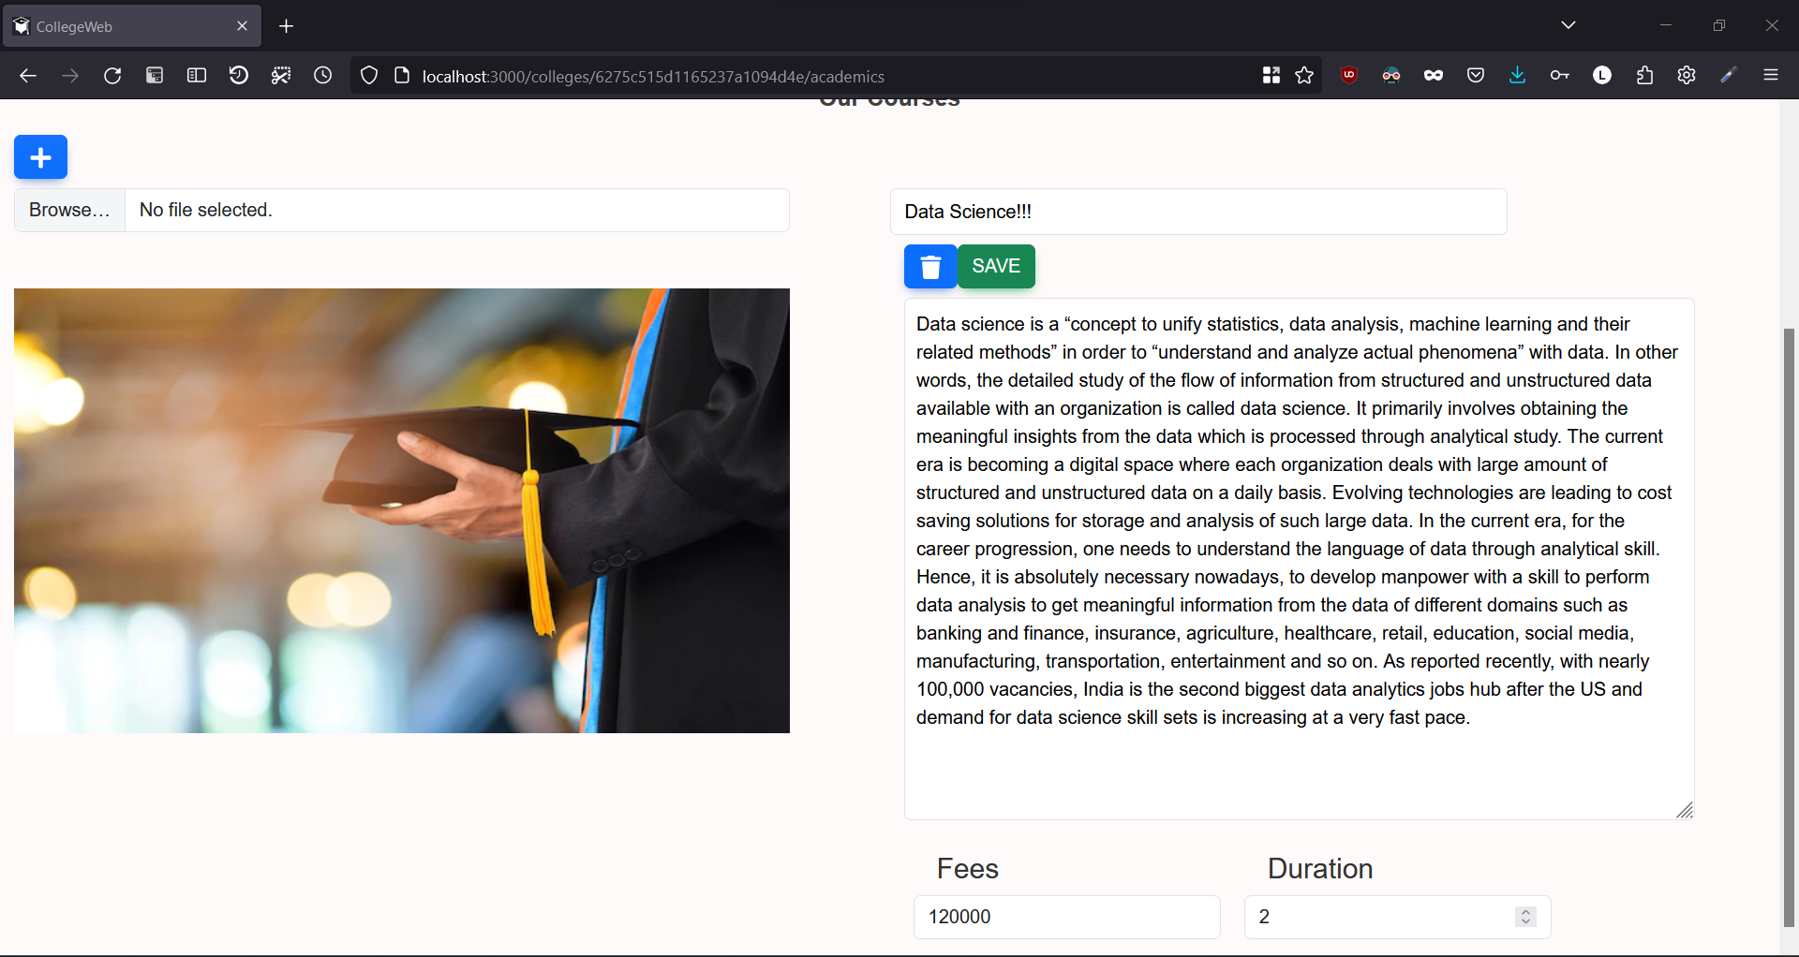

**College Notice**

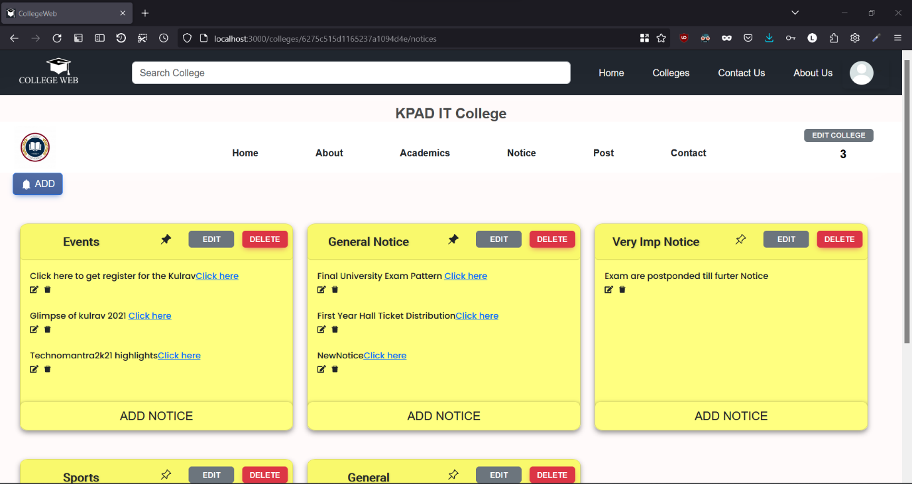

**College Notice Edit**

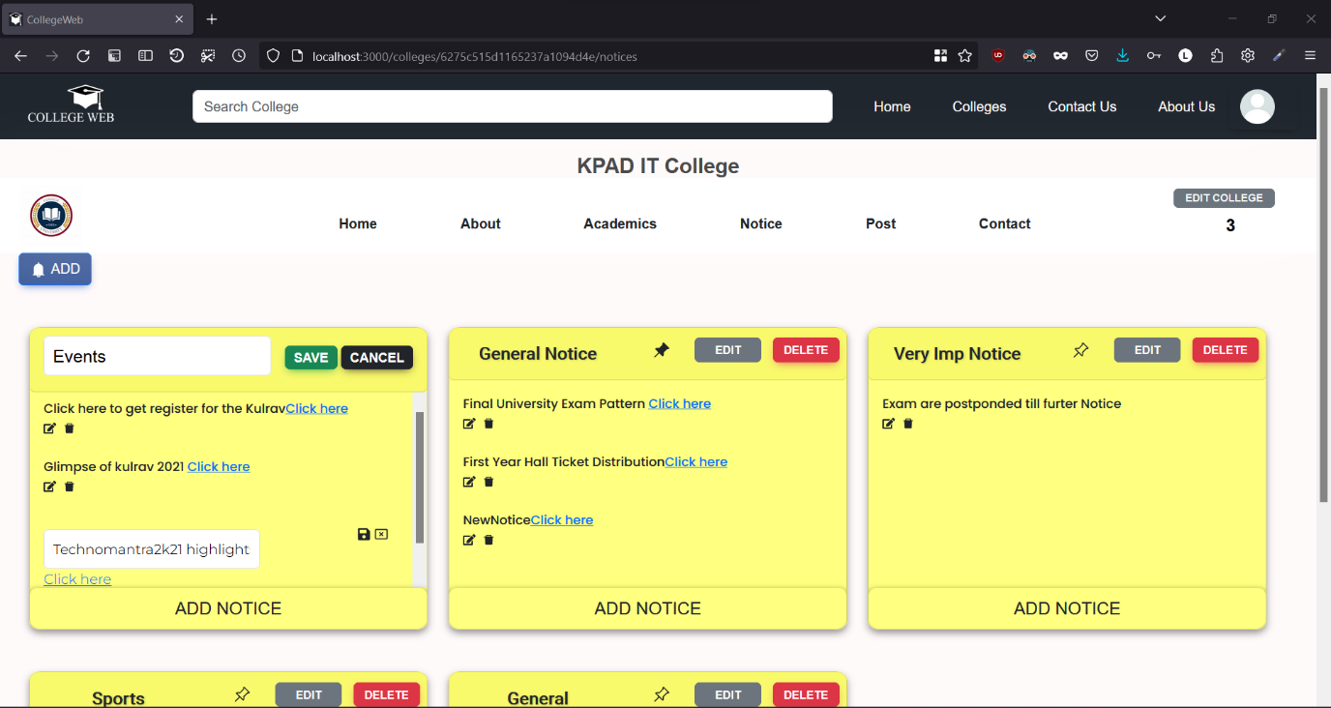

**Post**

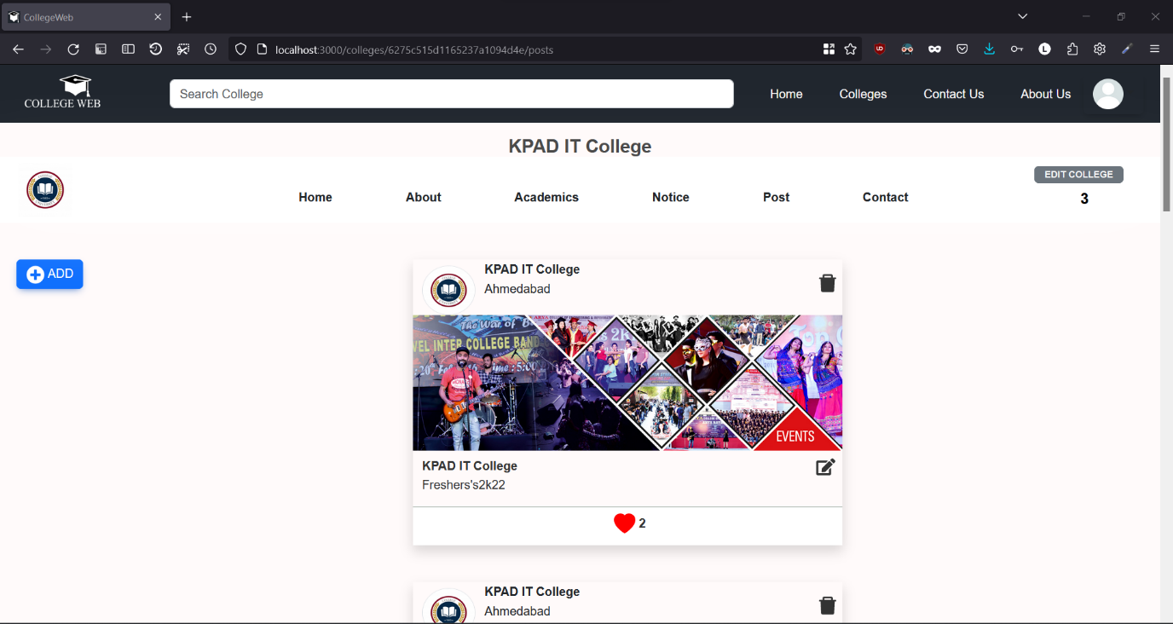

**Add Post**

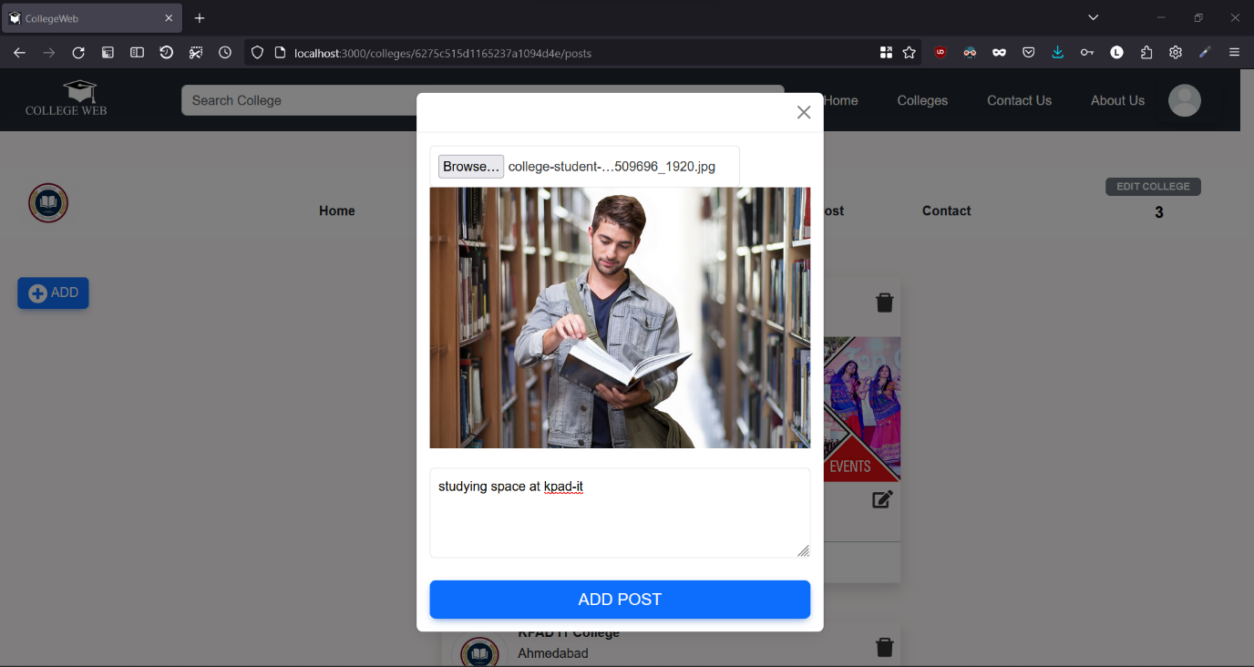

**College Contact Us**

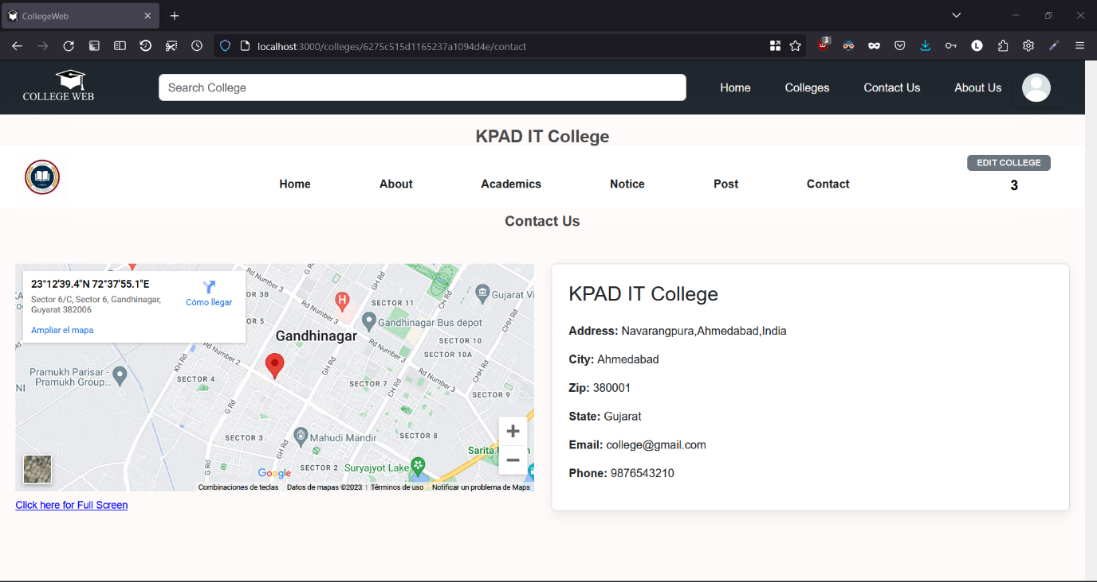

**Edit Profile**

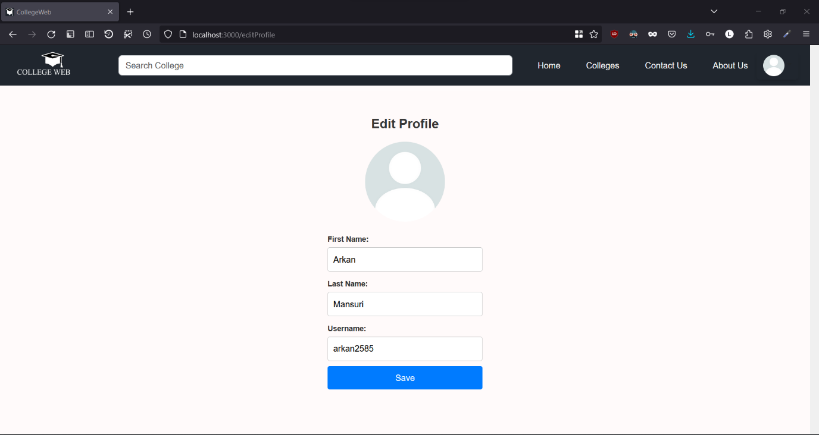

**Followed Colleges**

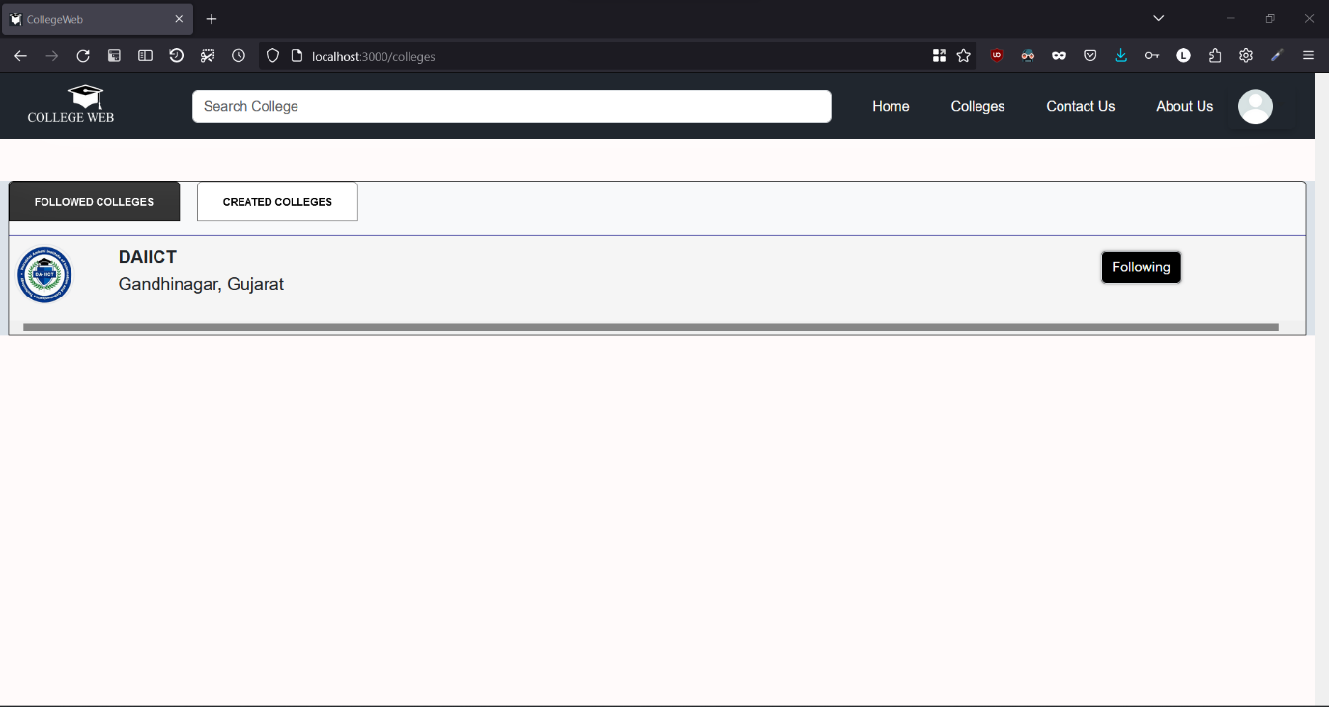

**Created College Page**

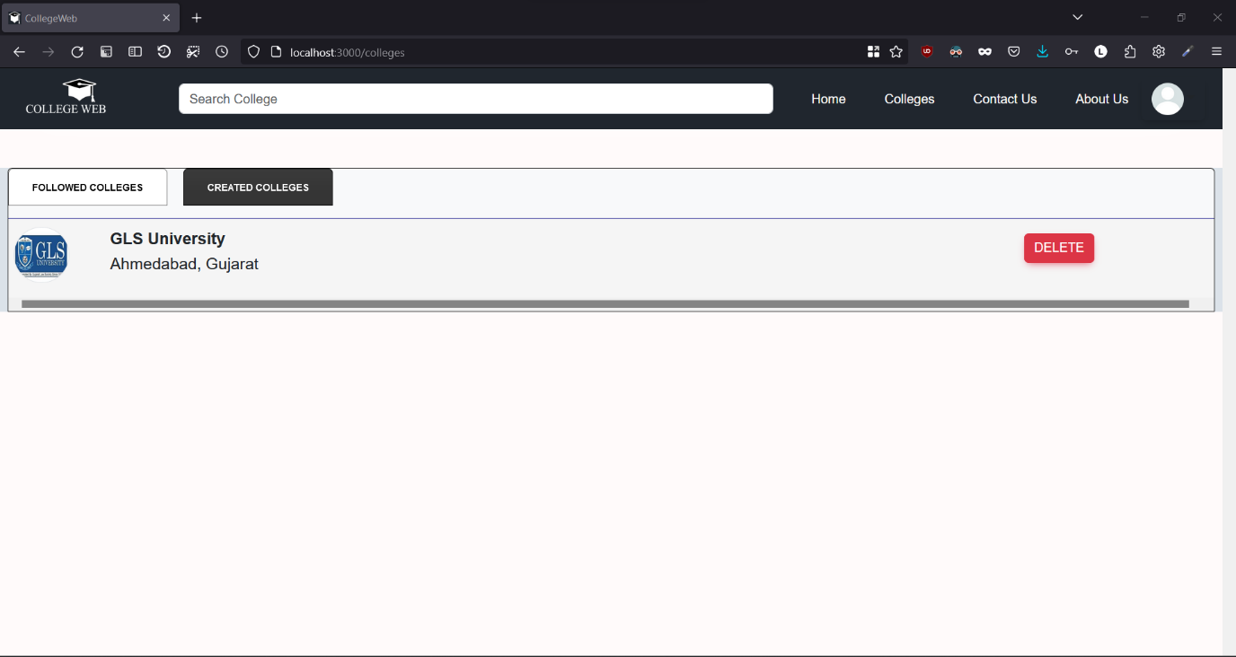

**User Home View**

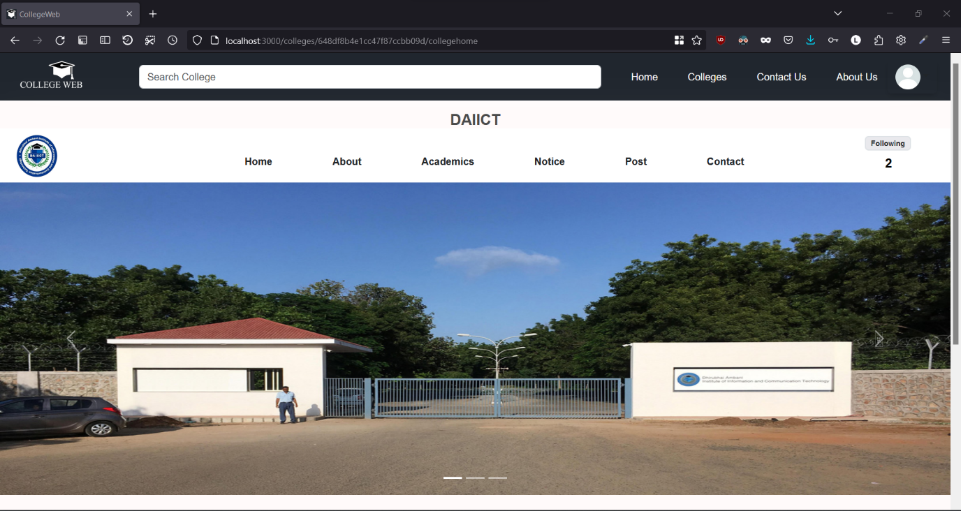

**User Home View 2**

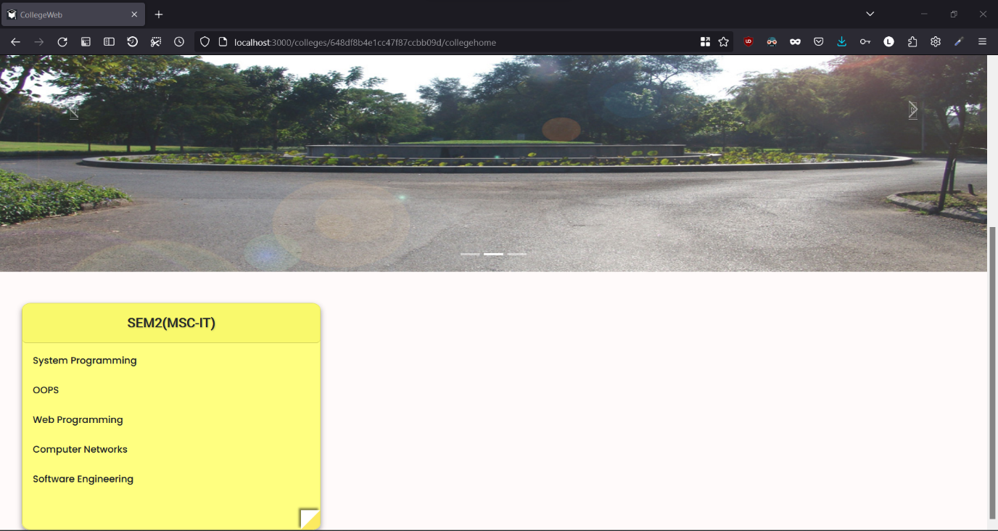

**User Academics Page**

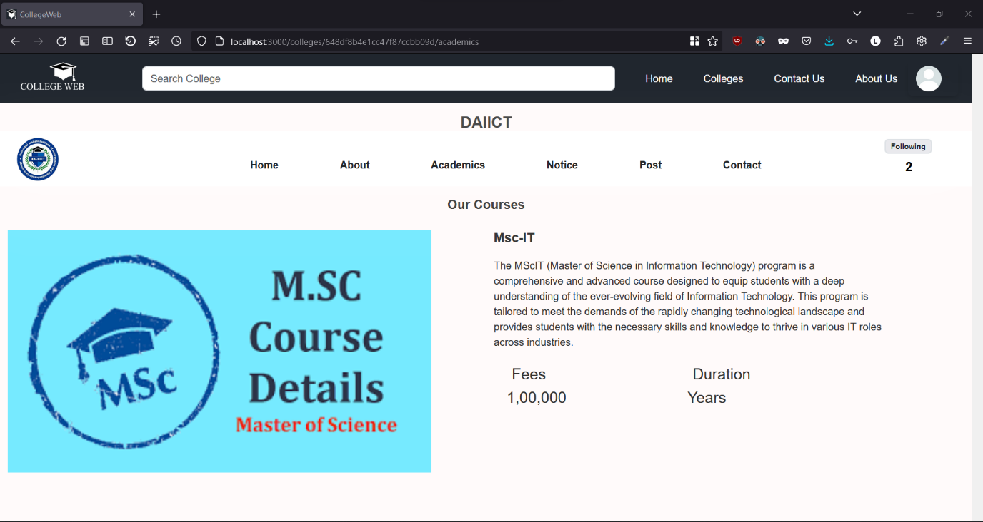

**User Notice**

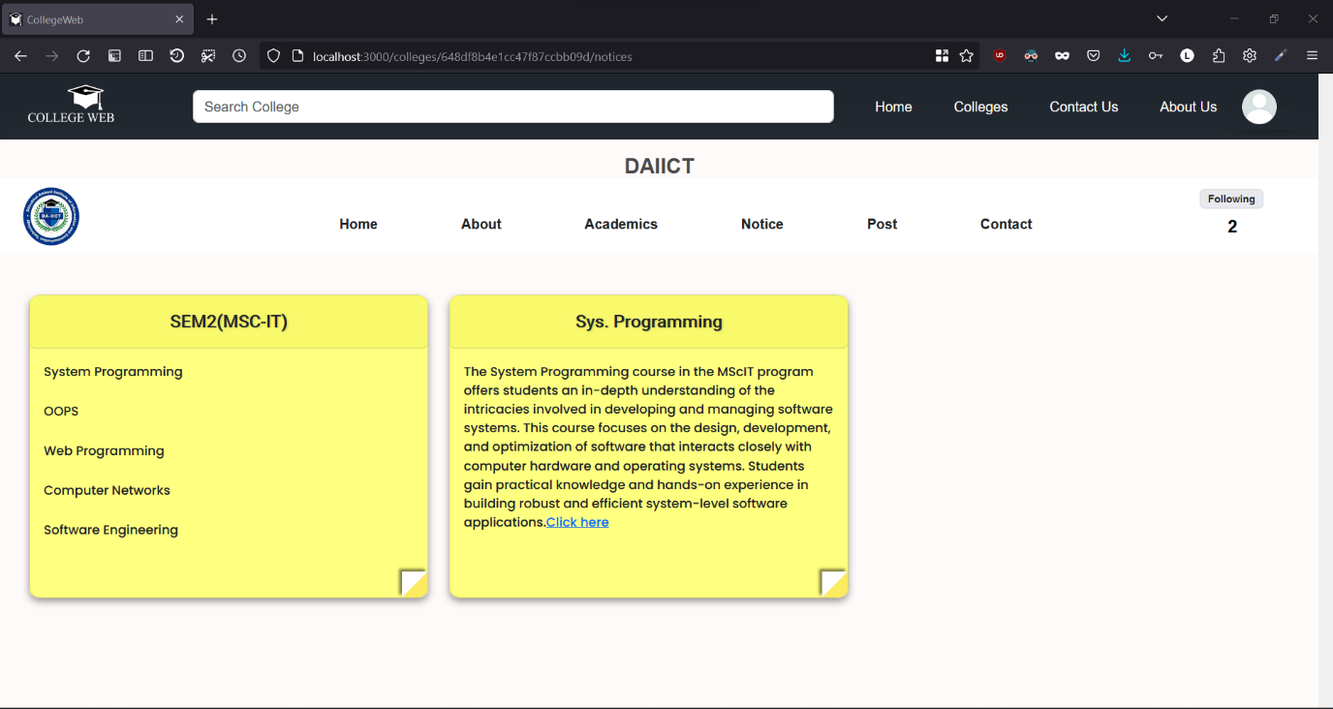

**User Contact Us**

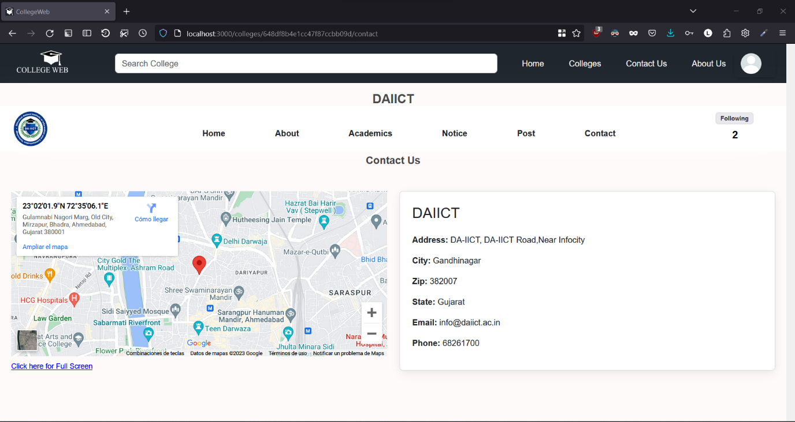

**User Post**

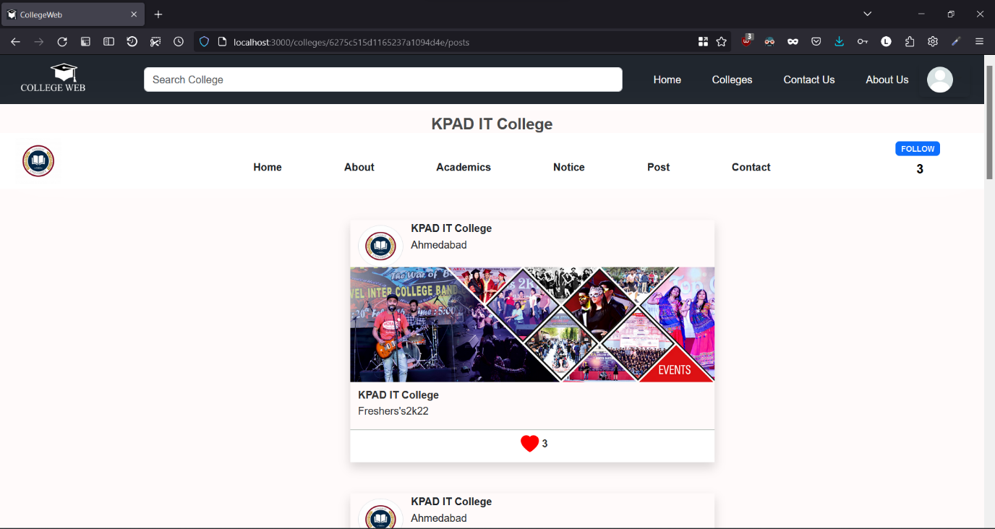

**Summary and Lessons Learned**

The CollegeWeb project was a collaborative effort by two college students during their internship, aimed at revolutionizing college-student interactions. Following Agile practices, they developed a web platform using ReactJS, ExpressJS, NodeJS, and MongoDB. The platform successfully enabled seamless connections between colleges and students, offering key features like user registration, college profiles, course-based searches, and a review system. The project taught valuable lessons in teamwork, effective communication, and user-centered design, resulting in a polished final product that empowers students in making informed decisions about their higher education journey. This journey of growth and learning has prepared them to deliver innovative solutions in the world of software development.

We have learned the following things:

* Designing a website keeping different screen size so that website can be visible from all the different device.
* Learn to use Bootstrap, ReactStrap, Postman.
* Working with third parties apis like cloudinary,netlify,

Open street map,Passport, and render

* Deploying Website on the World Wide Web.
* Comprehending user needs and collaborating as a cohesive team to ensure timely project completion.

**Conclusion**

We found immense joy in collaborating on the project "College Web." Throughout this journey, our esteemed mentor, Prof. Amit Mankodi, played a pivotal role in elevating the project's overall quality. Despite facing considerable challenges during development, we embraced the opportunity to learn and grow, unearthing a wealth of new knowledge along the way.

This project marks merely the beginning of our venture into innovative project development, leaving us eager to explore uncharted paths and set new ambitious goals to conquer.

**Bibliography**

* <https://react.dev/learn> -for react learning
* <https://www.w3schools.com/nodejs/> -for node js references
* <https://www.mongodb.com/docs/> -for mongo db query reference
* <https://expressjs.com/> -for express learning
* <https://reactstrap.github.io/> -for reactstrap queries